

**Semester 2, AY 2021-22**

**BC2407 ANALYTICS II ADVANCED PREDICTIVE TECHNIQUES**

**SEMINAR GROUP 4**

**GROUP PROJECT REPORT**

*Prepared for:*

**Hyeokkoo Eric Kwon (Prof)**

*Prepared by:*

|  |  |
| --- | --- |
| **NAME** | **MATRICULATION NUMBER** |
| Chan Yi Xuan | U2010972F |
| Jerome Chew | U2021304E |
| Jordan Low | U2010804E |
| Teresa Zhang | U2022886C |

**Team 8**

**Date: 3rd April 2022**

Table of Contents

Table of Contents 2

Executive Summary 4

1. Introduction 5

1.1 Business Problem 5

1.2 Significance of Business Problem 5

1.3 Current Frameworks and Limitations 7

1.4 Proposed Framework 7

1.5 Relevance of Proposed Framework 9

2. Severity Prediction Model 10

2.1 Current Approach 10

2.2 Our Approach 10

2.3 Data Source 13

2.4 Data Cleaning 13

2.5 Data Exploration & Analysis 13

2.5.1 Insight 1: Age 14

2.5.2 Insight 2: Nasal Congestion 14

2.5.2 Insight 3: Sore throat 15

2.6 Data Modelling 15

2.7 Comparison of Models 16

3 ICU Admission Model (IAM) 17

3.1 Current Approach 17

3.2 Our Approach 17

3.3 Data Cleaning 19

3.3 Data Exploration & Analysis 19

3.3.1 Insight 1: Age Percentile 20

3.3.2 Insight 2: Heart rate 20

3.3.3 Insight 3: Neutrophils 21

3.3.5 Insight 5: All variables in general 22

3.4 Data Modelling 22

3.5 Comparison of Models 23

4 Limitations 24

APPENDIX A: R Outputs of Severity Prediction Model 26

Multinomial Logistic Regression Model 26

Random Forest Model 27

Neural Network Model 28

Comparison of All Models 30

APPENDIX B: R Outputs of ICU Admission Model 31

Multinomial Logistic Regression Model 31

Random Forest Model 33

Neural Network Model 34

Comparison of All Models 36

APPENDIX C: Data Dictionary 37

Severity Prediction Model 37

ICU Admission Model 38

APPENDIX D: Usage Roadmap of Mobile Application 41

APPENDIX E: Usage Roadmap of ICU Checker Software 41

Appendix F: Data Cleaning 42

Appendix G: Data Exploration 42

Severity Dataset 42

Continuous Variables 42

Categorical Variables 43

ICU Dataset 46

Categorical Variables 54

APPENDIX H: References 56

Executive Summary

COVID-19 has become a part of our daily lives and it has undoubtedly brought about a huge amount of uncertainty and difficulty. As the number of infected grows, so does the strain on the healthcare industry. Hospitals are getting overcrowded with insufficient beds and the healthcare industry lacks the manpower resources to deal with the surge in the number of patients. This highlights the importance of maximising the limited healthcare resources available by ensuring that healthcare resources are given to those who need them most. Our framework strives to help reduce the strain on healthcare institutions during this COVID-19 pandemic and for future pandemics as well.

Our framework, “Hospital Framework” consists of a 2-prong approach to facilitate the efficient allocation of healthcare resources.

The first prong targets the A&E sector, which is overwhelmed by the number of COVID-19 positive patients who are seeking medical expertise even when their symptoms are mild and non-existent. This escalates the waiting time at the A&E and takes up a lot of time for doctors to evaluate each patient one by one, only to recommend most of them to undergo a Home Recovery Programme. This causes great inefficiency in the A&E department as time and other healthcare resources spent on these low-priority patients could be better used elsewhere, such as for patients with a more severe case of COVID-19 or other serious non-COVID-19 related illnesses or injuries. Thus, our first step aims to help these COVID-19 positive patients identify the severity of their condition based on their symptoms and recommend to them the necessary steps to take, be it to visit a hospital or simply isolate themselves at home. This would provide a greater sense of security and reduce the need for everyone to head to the A&E department when it is not necessary. We hope that our Severity Prediction Model (SPM) would be able to give COVID-19 positive citizens a peace of mind and to reduce the wastage of healthcare resources at hospitals’ A&E departments.

The second prong targets the ICU admissions and level of care at the hospitals. Given the increase in the number of patients being hospitalised due to COVID-19, the strain on the healthcare industry is evident with nurses having to handle almost double the number of patients they are used to handling. This reduces the amount of care given to each patient at the hospital. However, it is important that each patient still receives adequate care and thus we introduced our ICU Admission Model to identify patients who are likely to be admitted into ICU and label them to be high risk. By categorising patients according to their risk levels, it would allow healthcare workers to identify those who need greater medical attention and be better prepared in the event of an admission to ICU wards.

1. Introduction

The COVID-19 pandemic has stretched Singapore’s already scarce hospital resources (Abu Baker & Mohan, 2020). This is especially so with the Delta and Omicron variants, where the virus is extremely contagious, but the symptoms are mostly mild. Due to the unfamiliarity with COVID-19, positive patients will rush to visit the Accident and Emergency (A&E) department even though in most cases, their infection is mild and does not require medical attention.

The sheer number of patients going to A&E causes a knock-on effect in other hospital departments, with staff being sent to help in the A&E. Manpower in other wards is reduced due to the redeployment, causing an almost doubling of workload in some cases. This would be detrimental to patients in those wards as they would consequently receive less attention.

As a result of the high surge in patients in hospitals, medical decision-making shifted from achieving the best outcomes for individual patients to addressing the immediate care needs of patients. This is because healthcare workers would be stretched and would have to look after even more patients and reduce the quality of care. This has led to the progression of serious conditions among some patients who would have benefitted from earlier diagnosis and intervention (French, et al., 2021). It is also often hard for medical staff to tell whose condition will worsen and will need ICU care at the early stage of the disease.

There is thus a **need for developing a method of prediction for the patients who might potentially face a deterioration of their condition and potentially need intensive care**. This would thus help medical staff to prioritise care to such patients and be more efficient in resource allocation.

1.1 Business Problem

Ultimately, the **business problem is that hospital resources are not allocated to the patients that need it the most**.

It would thus be of utmost importance to determine:

* Whether COVID-19 positive individuals need to visit a doctor
* The level of care necessary for COVID-19 positive individuals who have been hospitalised.

Our project aims to assist MOH in predicting the potential severity of COVID-19 and the resulting need for hospitalisation and/or intensive care using machine learning models.

1.2 Significance of Business Problem

COVID-19 was not a pandemic that the world was prepared for and has severely impacted the entire world. Considering this, we hope that the use of machine learning models can help us reduce the strain on healthcare resources by allocating limited healthcare resources to those with higher priority. Moreover, the models can help us better prepare for future pandemics that are similar in nature.

With the Delta wave hitting its peak in mid-2021, many hospitals were overwhelmed with COVID-19 patients needing intensive care, and doctors all over the world were often forced to determine who to accept or reject into Intensive Care Units (ICUs) based on their own expert judgement of the patient's condition. While this is not the case in Singapore, our healthcare system did face a “considerable risk of being overwhelmed” (Lai, 2021).

More recently it is said that the daily case numbers may rise even further before peaking and may remain moderately high for some time before coming down. The Singapore government will continue to closely monitor the capacity of our healthcare system and prepare for further surges in infections. During this period, Singapore’s strategy remains to safeguard our healthcare capacity and focus resources on managing severe cases and protecting vulnerable patients.

Unnecessary medical attention to low priority patients

Daily cases started to rise exponentially from the end of August 2021. The number of individuals with mild symptoms has increased very rapidly. This has put a strain on our overall healthcare and response system and on our healthcare workers, as many COVID-positive individuals with mild symptoms are seeking medical attention at our hospitals when it might not be necessary. (Ministry of Health, 2021). Of the patients who walked into Khoo Teck Puat Hospital’s A&E in February 2022, 66% were discharged without being hospitalised (CNA,2022).

ICU and level of care

The level of care in hospitals has been falling due to the high surge of hospitalised patients. This is due to the misplaced and diverted attention of medical staff and has led to unnecessary deaths and complications.

While Singapore has the resources to increase intensive care unit (ICU) capacity, it lacks the manpower to man the additional units effectively, said Senior Minister of State (SMS) for Health, Janil Puthucheary, in Parliament. As beds increase, the healthcare workers would be stretched as each healthcare worker would have to look after even more patients, reducing the quality of care given due to the lack of hands or time. (Yong, 2021)

Admission into ICU is purely based on the vital signs of each individual patient and due to the stretched capacity of all hospitals, vital signs are only periodically measured by the nurses depending on the instructions of the doctors. Thus, this results in a lack of differentiation between the level of care for each patient and there is also no way for the staff to determine the level of care certain patients require.

Therefore, our group wanted to create a model that can help quickly predict the severity of the infection by looking at the symptoms and predicting the healthcare resources needed for each patient so that they can be allocated accordingly to minimise wastage and increase efficiency.

1.3 Current Frameworks and Limitations

There are currently no models for the prediction of severity of infection or need for intensive care. This as a result has led to the inefficiencies described in hospitals stated above.

Covid Protocol

Currently, under COVID-19 Health Protocol 1 by the Singapore government, high-risk individuals/individuals with severe significant symptoms are to undergo ART and PCR test and the doctor would convey those with severe symptoms to the hospital for further assessment. However, the severity of the individuals’ covid symptoms is determined by the individual and not based on any given set of metrics. Thus, it is ambiguous as to how an individual identifies the severity of his or her condition. This creates an air of uncertainty amongst many citizens, and they naturally would just proceed to seek further medical attention just to play it safe. However, this does lead to potential wastage of time and resources on patients of low priority.

A&E Specific Situation  
For those who have chosen to visit a hospital, they are usually triaged in the Accident and Emergency department with most being sent back home after their visit as their cases are deemed not serious enough by the hospital.

A more detailed explanation is detailed in section 2.1 of this report.

ICU and Level of Care

Currently, given the lack of healthcare workers due to the COVID-19 pandemic, each nurse is now required to take care of more patients, about 12 patients each, which is double of what they are used to handling, which lowers the average quality of care given to each patient (CNA,2022). Given the magnitude of the pandemic, the higher patient-nurse ratios are inevitable which ultimately reduces the level of care for each patient as lesser time and attention is given to them. Patients in the general wards are randomly allocated to nurses in batches and are given equal care. However, given the increasing strain on the healthcare workers with more and more patients flooding into hospitals, it limits the quality of care given, and thus, it is increasingly important to prioritise the level of care given to certain patients. Patients with a higher risk of entering ICU should be identified and given more attention so that healthcare workers are more prepared to attend to their needs in the event they require ICU admission.

1.4 Proposed Framework

Our proposed approach can be summarised in the flowchart below:

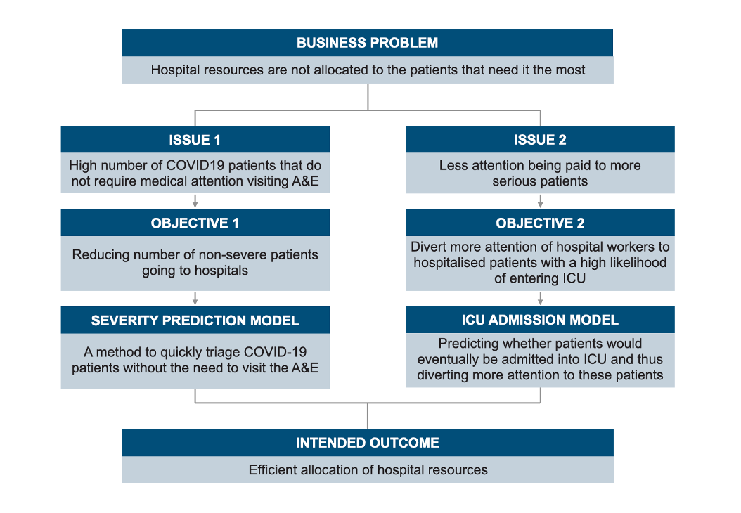

*Figure 1: Flowchart of the two-pronged approach*

Our objective of optimising hospital resources can be summarised into 2 objectives:

* Decreasing the number of patients with a low likelihood of severe illness visiting the hospitals, thereby reducing strain on the hospitals
* Diverting more attention of hospital workers to hospitalised patients with a high likelihood of entering ICU

To achieve our objectives, our proposed approach will be split into 2 phases:

**Severity Prediction Model**

A method to quickly triage COVID-19 patients by predicting the severity (and hence the likelihood of hospitalisation) using just the symptoms of the patients without the need for patients to visit the A&E department. Severity is split into three categories – mild, moderate, and severe. Our model recommends only those that fall under the moderate and severe categories to visit the A&E department.

**ICU Admission Model**

Of those that are hospitalised, by using their vital signs and other measures from a blood test, we would predict whether they are likely to be admitted into ICU, where ICU admission would be our binary outcome variable. Fewer resources will thus be allocated to patients with a low potential of being admitted into ICU and more resources allocated to patients with a high potential of being admitted into ICU, hence allocating more resources to those who need it more.

1.5 Relevance of Proposed Framework

Relevance of Predicting Severity of infection

This machine learning model can be developed and used once sufficient data has been gathered, this would contrast with that of traditional methods of testing which would take months to develop in a lab and subsequently even more time to mass produce in factories and distributed to the public. This is significant because our model of predicting the presence and severity of infection would be based on symptoms and other readily available information such as potential close contact and age. Practically, this could be generated into an online system for anyone to check and determine if they are at risk of infection as well as determine their potential severity. Governments could also then customise recommendations for different levels of infected risk and severity based on their own country’s healthcare system. This could be in the form of whether suspected patients should stay home, visit a clinic, or seek out a hospital.

Relevance of Predicting the need for Intensive Care

With the second portion of our project, our machine learning model, we would be able to expedite and complement a doctor’s decision on whether an infected patient needs to stay, be discharged, or be sent to intensive care. With a simple blood test, we would be able to predict the need for intensive care much faster and more accurately than what a team of nurses and doctors can do when dealing with a high influx of patients at maximum capacity.

By doing so, hospitals would be able to better categorise their patients according to their potential need for ICU in the future. Given the increasing strain on healthcare workers due to the increasing number of COVID-19 cases, it would allow healthcare workers to prioritise patients at higher risk determined by their risk of entering ICU. With more patients under the care of each healthcare worker, it would help by diverting greater attention to patients who need it the most.

This would therefore be extremely useful for hospitals and the healthcare industry when dealing with a flood of patients to determine the level of care a patient needs way before his or her situation worsens.

Relevance Beyond COVID-19

Even though the models that we are proposing are targeted at the current pandemic, it is still relevant even as Singapore transitions to living with COVID-19 and the strain on hospital resources is relaxed. COVID-19 will not be the last pandemic that will hit the world and experts are calling on governments to start preparing for the next pandemic (Plump, 2021). Hence, the models could be quickly applied to future pandemics after sufficient data is made available.

2. Severity Prediction Model

2.1 Current Approach

Currently, according to the Singapore government’s healthcare protocol, it is advised that individuals with severe COVID-19 symptoms are to undergo an ART and PCR test and visit a doctor. However, it is ambiguous as to how an individual identifies the severity of his or her condition. This creates an air of uncertainty amongst many citizens and they naturally would just proceed to seek further medical attention just to play it safe. However, this does lead to potential wastage of time and resources on patients of low priority.

The procedure for any patients, including COVID-19 positive, who visit the A&E are first being classified into the following 4 levels of priority:

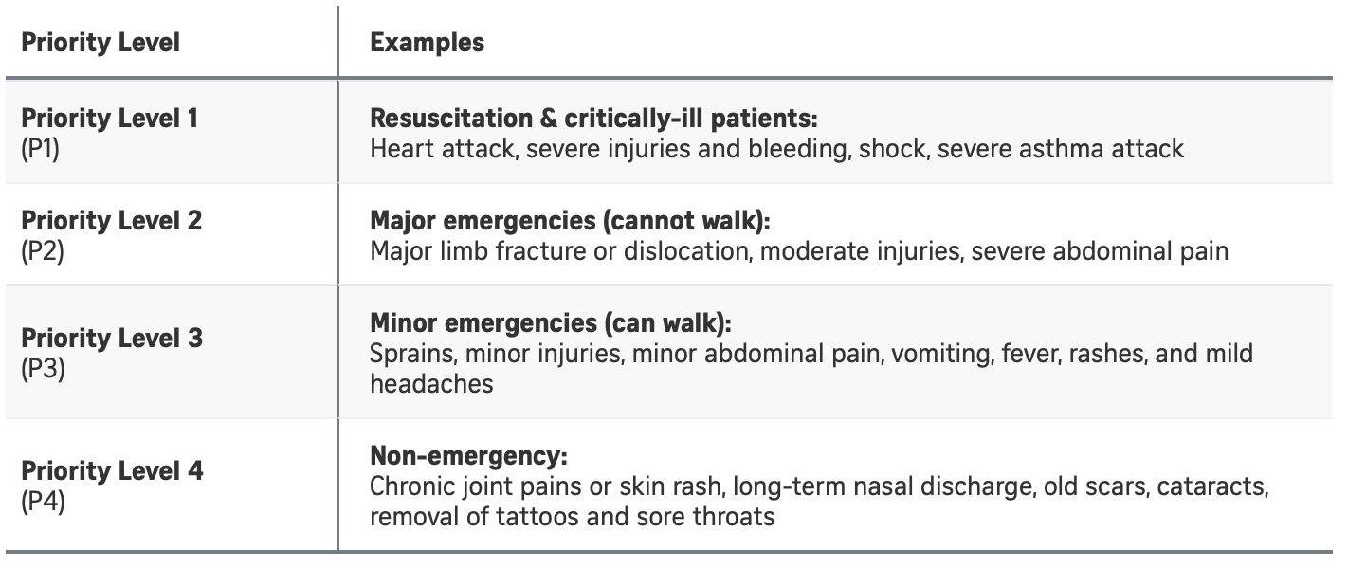

*Figure 2A: Priority levels for A&E patients*

(Woon, 2022)

After they have been classified, all patients, regardless of priority levels, will have to see a doctor before being discharged. This creates an inefficiency in hospital resources as time and resources are required to address patients of low priority which takes the attention away from high priority patients who have a greater need for medical care. According to an A&E doctor, two-thirds of COVID-19 positive patients who visit the A&E fall into priority levels 3 and 4. Due to the high number of patients who do not require medical attention but still visit the A&E, waiting time has ballooned to over 6 hours (Woon, 2022). One-third of COVID-19 positive patients are then held back in receiving more timely medical attention.

2.2 Our Approach

We aim to develop a checklist that COVID-19 positive patients can easily access through a mobile application. Patients would be able to input their age, as well as the presence of a few COVID-19 symptoms. The checklist would be able to inform the patient if a visit to the hospital is necessary. *Figure 2B* shows a mockup of our mobile application

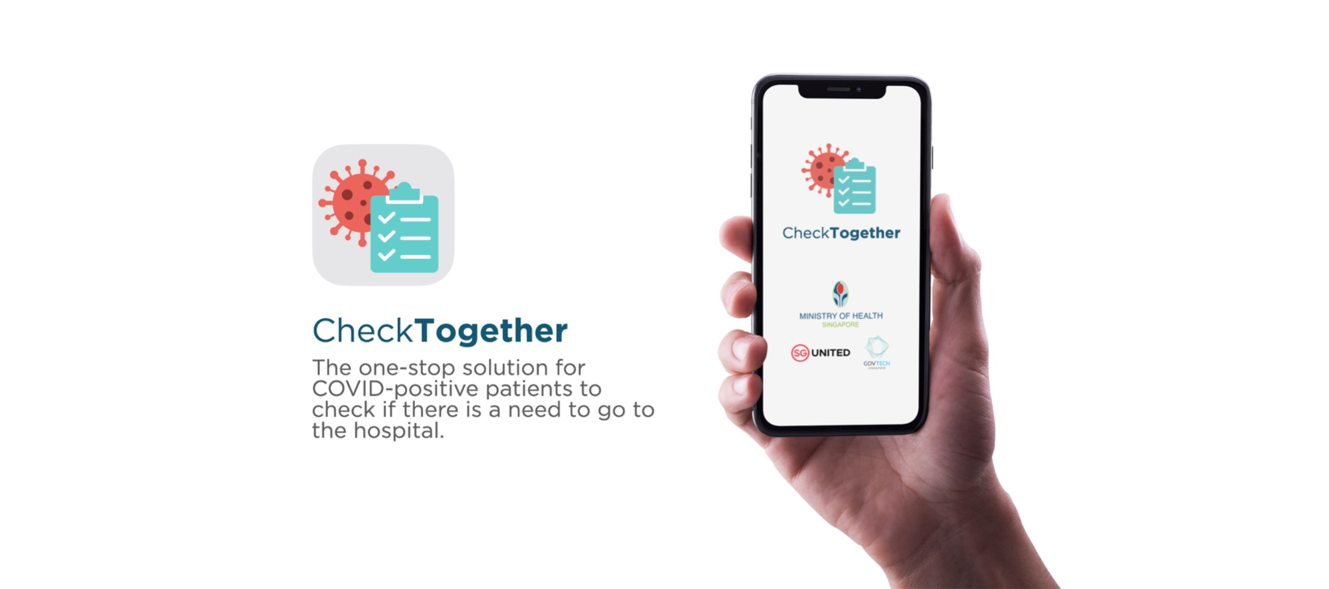

*Figure 2B: Mockup of CheckTogether App loading screen*

The homepage of the application would contain a dashboard similar to the TraceTogether app, showing the patient’s vaccination status as well as their infection status:

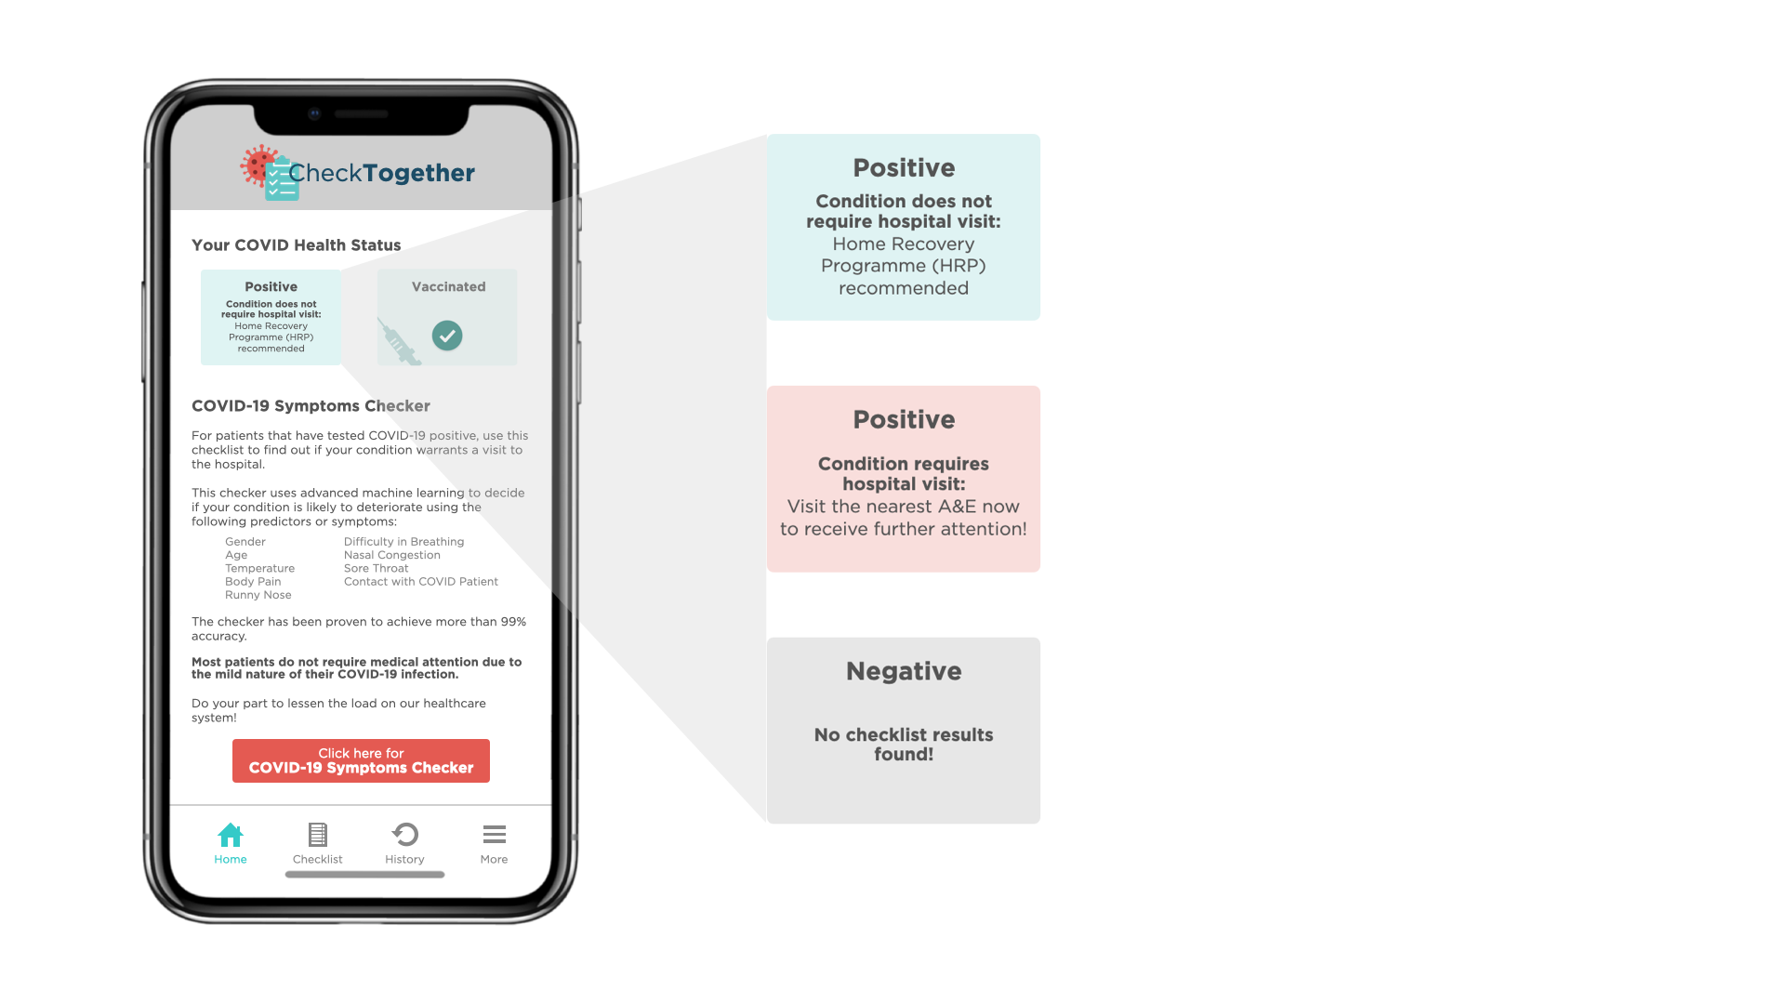

*Figure 2C: Mockup of CheckTogether App Homepage*

With reference to *Figure 2C*, these are 3 different statuses that may be displayed on a patient’s dashboard

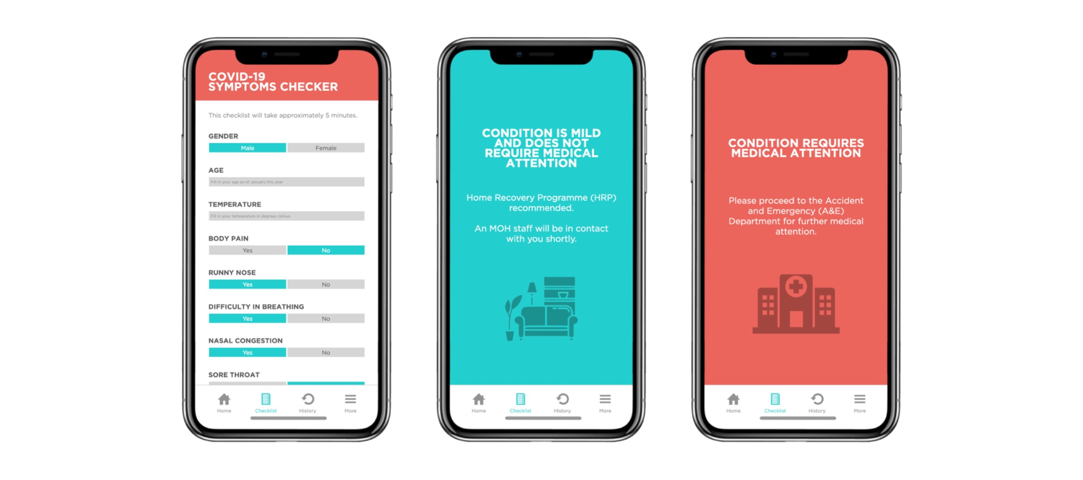

*Figure 2D: Mockup of Severity Prediction Interface in CheckTogether App*



*Figure 2E: Mockup of Severity Prediction Results in CheckTogether App*

With reference to *Figure 2E*, the leftmost mock-up is how the checklist will look like. The checklist is designed to be completed within 5 minutes and would be easy to use, even for the elderly. Upon completing the checklist, the application will display one of the 2 mock-ups seen in the centre and right of *Figure 2E*, depending on the predicted severity of the infection. Refer to Appendix D for a detailed usage roadmap of our proposed application.

The decision on whether the patient’s infection is serious enough is based on a machine learning algorithm that we built. The decision algorithm will be elaborated in section 2.7.

2.3 Data Source

The dataset is sourced from Github’s repository (Pandey, 2020) The dataset contains 2500 instances or records of 11 characteristics and includes demographic and clinical data for individuals diagnosed with COVID-19 or viral respiratory function. Refer to Appendix C for the full list of variables.

The outcome variable is Severity and it is a 3 level categorical variable with the levels: Mild, Moderate, and Severe. The following describes the clinical implications of the 3 classifications (COVID-19 Clinical Management Committee (CCMC), 2021):

* **Mild**: Patient experiences common flu symptoms that can be managed at home or via telemedicine. No imaging or laboratory tests are required.
* **Moderate**: Patient experiences lower respiratory disease during clinical assessment or imaging and requires monitoring in a hospital setting.
* **Severe**: Patient experiences oxygen deficiency (SpO2 < 94% on room air, or P/F ratio of <300 mmHg, or respiratory rate of >30 breaths/minute), leading to possible rapid clinical deterioration. Patients require close monitoring in a hospital setting.

Based on the clinical implications above, the application will recommend patients classified as ‘Moderate’ and ‘Severe’ to visit the hospital.

2.4 Data Cleaning

The dataset is complete and does not have any null values. However, a few steps had to be done to make the data set suitable for analysis.

1. The country variable was dropped as it had no relevance in our analysis.
2. Temperature was converted from degrees Fahrenheit to degrees Celsius.
3. Contact_with_covid_patient had 2 responses that had the same significance: ‘Yes’ and ‘yes’. Rows with ‘yes’ were converted to ‘Yes’.
4. All variables apart from Temperature and Age were factorised.

Afterwhich, the team conducted a 70-30 train-test split on the dataset using the outcome variable ‘Severity’. In the end, the train set contained 1750 unique observations while the test set contained 749 unique observations.

2.5 Data Exploration & Analysis

To have a brief idea of the relationship between the predictors and Severity before doing machine learning, we plotted the predictors against Severity to do a bivariate analysis. Within the dataset, there are significant variables that play a vital role in determining the severity of the illness. Some insights can be generated from the visualisations with observable trends as shown below.

# 2.5.1 Insight 1: Age

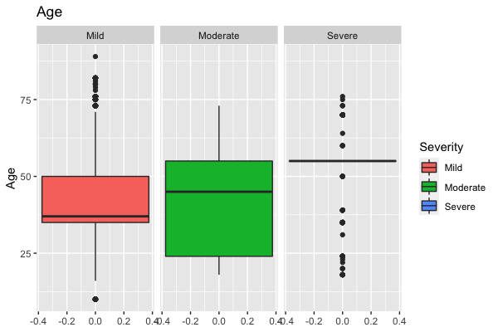

*Figure 2F: Boxplot for Age*

Looking at the median of age across the different levels of severity, with severe patients having the highest median and mild patients having the lowest median, there is a correlation between age and severity. The older the patient, the more severe the disease.

# 2.5.2 Insight 2: Nasal Congestion

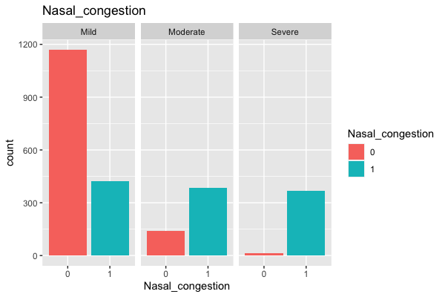

*Figure 2G: Barplot for Nasal Congestion*

The proportion of patients with nasal congestion increases as the severity increases, thus suggesting that nasal congestion is a significant predictor of severity of Covid-19.

# 2.5.2 Insight 3: Sore throat

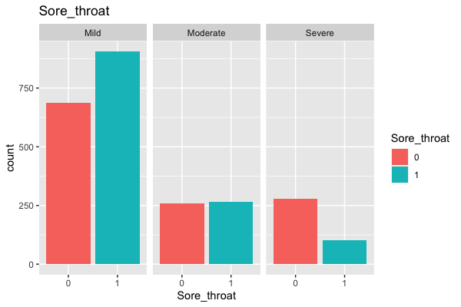

Figure 2H: Barplot for Sore throat

It is interesting to note that there is a higher proportion of Covid-19 patients with mild severity having sore throat, while severe severity has a higher proportion of patients without sore throat, suggesting that sore throat is negatively correlated to severity.

2.6 Data Modelling

The team has decided to compare between 3 machine learning models. The models were compared on various error matrices that will be elaborated in section 2.7.

Since the outcome variable is a 3-level categorical variable, Logistic Regression, Random Forest, and Neural Network are chosen as the possible prediction models.

Multinomial logistic regression was chosen as it is easier to implement and interpret. Additionally, logistic regression models are very efficient to train, which is beneficial when large datasets are present (Goyal, 2021). However, logistic regression models are susceptible to overfitting. To overcome this, the team conducted backward elimination to optimise the model (Pramoditha, 2021). In R, the package ‘nnet’ was used to conduct multinomial logistic regression. Since there are more than 2 categories in the outcome variable, the reference level was set to ‘Mild’.

Random forest was chosen as it reduces overfitting present in a single decision tree. In addition, random forest is robust to outliers and comparatively stable compared to other prediction models (Kumar, 2019).In R, the package ‘randomForest’ was used. The team plotted the out-of-bag (OOB) error graph to make sure that the OOB error stabilised before the default number of trees (500). It was found that the OOB error did stabilise after ntree=250 and hence the default setting could be used.

Since neural network requires input variables to be numeric (Brownlee, 2019), further pre-processing must be conducted for categorical variables to convert them into integers. The team experimented with a 1-hidden layer and a 2-hidden layer neural network and found that the 1-hidden layer neural network achieved lower error.

All 3 models were trained with the train set. Train and test set error was computed by running the respective data sets through the various models and comparing the predicted severity versus actual recorded severity. The error computation will be discussed further in the next section.

Detailed model description, confusion matrix, model plots, and OOB error plot can be found in Appendix A.

* 1. Comparison of Models

In comparing the 3 models, 4 different error matrices are used:

* **Total Error (TE)**: Proportion of total cases that have been misclassified
* **Mild Error (ME)**: Proportion of cases that is mild, but misclassified as moderate/severe
* **Moderate Error (MDE)**: Proportion of cases that is moderate, but misclassified as mild/severe
* **Severe Error (SE)**: Proportion of cases that is severe, but misclassified as moderate/severe

*Table 2* below shows the summary of the errors of the 3 models (in %, rounded to 3 decimal places):

|  |  |  |  |  |  |  |  |  |
| --- | --- | --- | --- | --- | --- | --- | --- | --- |
|  | TE - Train | TE - Test | ME - Train | ME - Test | MDE - Train | MDE - Test | SE - Train | SE - Test |
| Multinomial Logistic Regression | 2.000% | 1.736% | 0.000% | 0.210% | 4.348% | 1.274% | 7.090% | 8.686% |
| Random Forest | 0.571% | 1.335% | 0.898% | 2.096% | 0.000% | 0.000% | 0.000% | 0.000% |
| Neural Network (1 level) | 0.571% | 1.335% | 0.898% | 2.096% | 0.000% | 0.000% | 0.000% | 0.000% |

Table 2: Collated Error rates for Severity Prediction Models

As seen in *Table 2*, by comparing Total Error, both random forest and neural network had considerably lower errors in their test set. In fact, it is interesting to note that errors are exactly the same in the random forest and neural network models. In general, random forest and neural network models achieved excellent accuracy of less than 2% error across all error categories.

However, rather than looking at Total Error, the team feels that Moderate Error (MDE) and Severity Error (SE) have more clinical implications than the other error categories. MDE refers to the proportion of cases that are moderate but are misclassified as mild or severe. SE refers to the proportion of cases that are severe but are misclassified as mild or moderate. The clinical implications of having MDE and SE is that patients who need medical attention are being deprived of it because the application will recommend them to stay at home. This will lead to severe medical complications in delaying treatment. The MDE and SE of our random forest and neural network models are 0%, meaning that it accurately predicts severe and moderate cases 100% of the time.

Given that both random forest and neural networks achieve the same results, the team would select random forest as it is computationally less intensive and less time-consuming to train a new model given new data (Roßbach, 2018). In addition, less preparatory work has to be done to the data when training a new random forest model as compared to a neural network model.

3 ICU Admission Model (IAM)

3.1 Current Approach

As previously mentioned, there is a lack of care differentiation between patients who have been admitted to the hospitals. Patients are only admitted into ICU when they hit critical condition when it potentially might have been too late. Hospital staff are also stretched thin and would have to spread their attention equally among all patients which would not be ideal as some patients who are not qualified to be admitted into the ICU might still require a higher level of care and monitoring.

Moreover, doctors are also not used to making so many decisions so quickly as to who deserves a better chance at survival, saying they are not used to “drastic decisions” that are “wrenching” (Parodi et al., 2020). Thus, artificial intelligence might be better at making decisions quickly without being overwhelmed by emotions at deciding which patients require a higher level of care.

Additionally, the median time from symptom onset to severe hypoxemia and ICU admission is approximately 7–12 days. Although the rate of patients needing ICU care is currently unknown, 6.1% were classified as critical and 13.8% as severe. However, it is often hard for healthcare workers to tell who will need ICU care at the early stage of disease or presentation to the hospital (French, et al., 2021). Predicting the patients with COVID-19 needing ICU care may help prioritise the care of the patient.

3.2 Our Approach

To provide timely and adequate warning about whether a patient is about to be admitted into ICU, we first identified the periods just before they are admitted into ICU and then removed all data as to when they are already in the ICU as those data are not relevant. By using certain patient demographic information, blood results and vital signs as our independent variables to predict if a patient is about to go into ICU and if so, these patients will then be labelled to be of high risk and a greater level of care will be allocated to these patients.



Figure 3A: Mockup of ICUChecker Software

*Figure 3A* shows the prototype of our ICU admission model which is an analytics software based on machine learning algorithms to predict the likelihood of a patient being admitted into ICU.

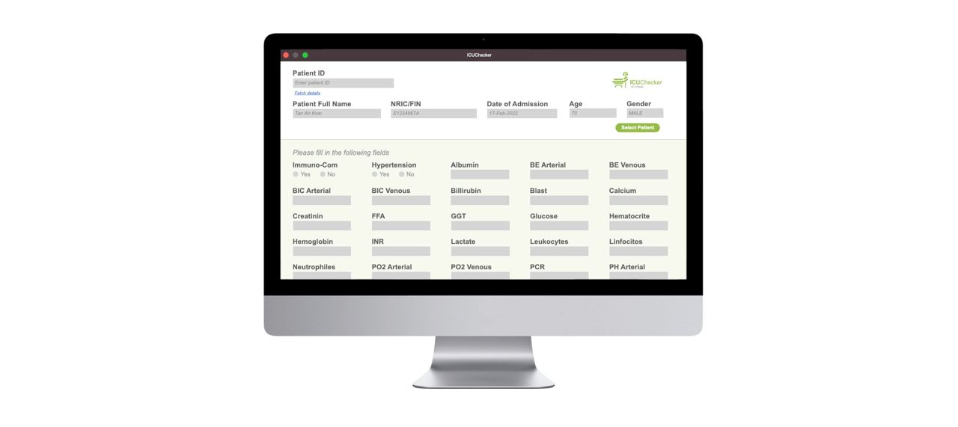

Figure 3B: Mockup of individual Patient dashboard ICUChecker Software

*Figure 3B* shows the user interface whereby the nurse or attending doctor will key in the relevant information of the patient, such as blood results and vital signs which would then be used to predict whether the patient is of high risk of entering ICU and therefore would be given greater medical care.



Figure 3C: Mockup of prediction of ICU admission model in ICUChecker Software

3.3 Data Source

The data set is sourced from Kaggle and contains anonymised data of patients diagnosed with COVID-19 that has been admitted to Hospital Sirio Libanes, Sau Paulo, Brazil. There are a total of 248 variables and 1925 unique observations in the data set pre-cleaning.

Each patient has 5 observations, each corresponding clinical indicators taken within each window as seen below:



Figure 3D: Window of patient observations in dataset

3.4 Data Cleaning

As seen in the diagrams below, the windows in which patients are already admitted into ICU will not be used in our data modelling and would be discarded instead.

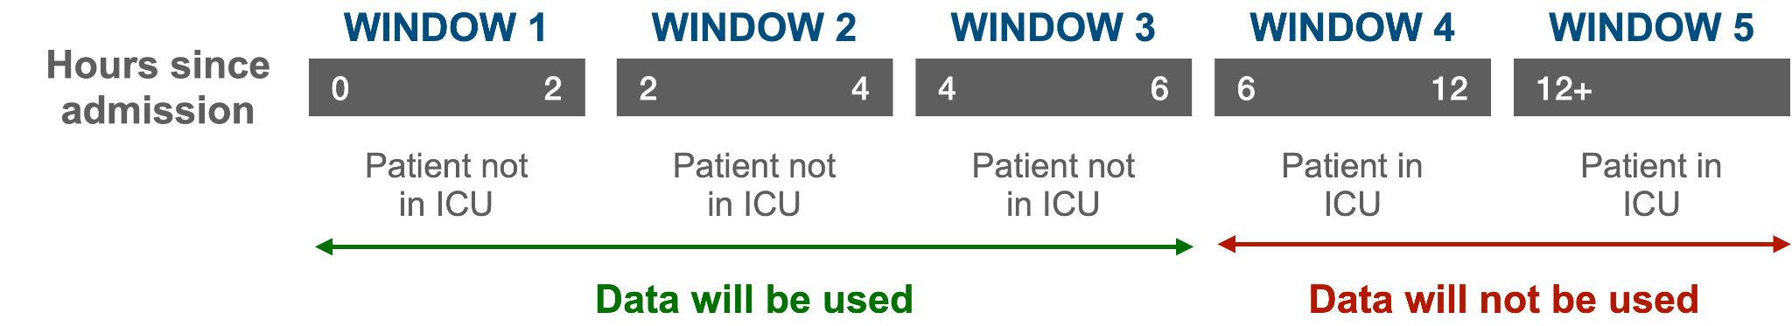

Figure 3E: Example of data filtering for ICU Admission model

We redefined our outcome variable, ICU, with “0” representing not admitted into ICU and “1” representing the period in which the patient is about to be admitted into the ICU in the very next window. To predict this outcome variable, we used the patient’s demographic information, blood results, vital signs, and blood gases as our independent variables to train our machine learning models.

In our original dataset, each patient’s data would be recorded in 5 consecutive rows where each row represented a time window, ICU status, and numerous variables.

The first step was to delete all rows with ICU = 1. This is because we are unable to review if the data collected when ICU = 1 is taken before or after the patient is admitted to the hospital as seen in *Figure 3D*.

Next, we change the 0 in the window right before ICU = 1 to 1 for each patient.

There are only 1424 rows of data to work with with more than 50% of the data missing (Appendix F). To have more data to work with, instead of removing the NA values, we replaced them.

We used rfImpute based on Random Forest to replace all NA values while creating new data tables, using ‘ICU’ as the Y variable to be predicted on. We feel that rfImpute is better than using median/ mean for continuous variables and mode for categorical variables as it considers the significance of each variable (Bhalla).

Finally, we exported each cleaned dataset which will be used in further analysis.

3.5 Data Exploration & Analysis

To have a brief idea of the relationship between the predictors and ICU prediction before doing machine learning, we plotted the predictors against ICU to do a bivariate analysis. Within the dataset, there are significant variables that play a vital role in predicting if a patient needs to go to an ICU. Some insights can be generated from the visualisations with observable trends as shown below.

Instead of doing data exploration on the dataset with NA values replaced with rfImpute, we did the data exploration on a dataset with all the NA values removed as the relationships can be seen more clearly.

There are a total of 48 predictors for ICU, to simplify things, we will only be drawing basic analysis on predictors that have shown a high significance level in the logistic function and are also commonly used in current hospitals for ICU admission assessments.

# 3.5.1 Insight 1: Age Percentile

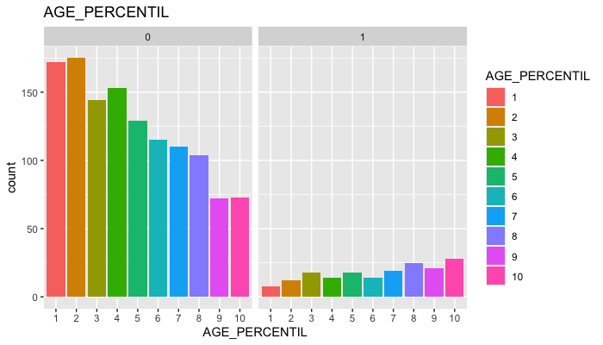

Figure 3F: Barplot for Age Percentile

For ICU prediction = 0, the age percentile is skewed towards the younger patients, while for ICU prediction = 1, the age percentile is skewed towards the older patients. This suggests that age plays a significant role in predicting ICU outcome, with older patients having a higher risk of going into ICU.

# 3.5.2 Insight 2: Heart rate

Figure 3G: Boxplot for Heart Rate

*Figure 3F* shows that those patients that are about to go into ICU generally have a higher heart rate compared to those that are not about to go to ICU, suggesting that heart rate has a positive correlation with ICU and is a significant predictor. This is true given that a faster heart rate signals larger stress placed on the heart to maintain a steady heartbeat (American Heart Association, 2021).

# 3.5.3 Insight 3: Neutrophils

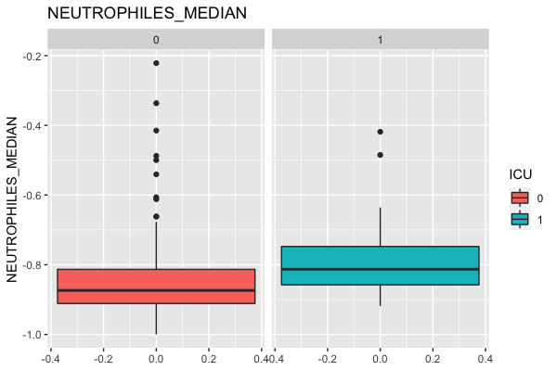

Figure 3H: Boxplot of Neutrophils

From *Figure 3G*, patients that are about to go into ICU have generally more Neutrophils. This is understandable especially since Neutrophils are an important type of white blood cell that helps to fight off bacterial infections (Fletcher, 2018).

# 3.5.3 Insight 4: Lymphocytes

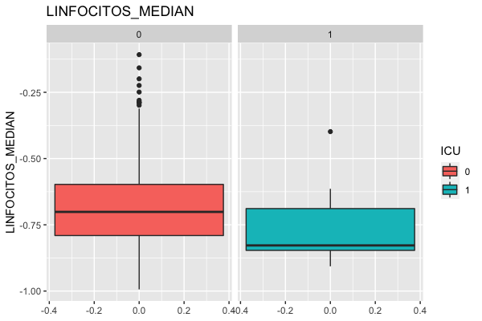

Figure 3I: Boxplot of Lymphocytes

From *Figure 3H*, patients that are about to go into ICU have generally less Lymphocytes. Asymptomatic patients showed higher levels of lymphocytes (a type of white blood cell responsible for immune responses), cleared the viral particles faster, and had lower risks of long-term complications (Huan, et al., 2020)

# 3.5.5 Insight 5: All variables in general

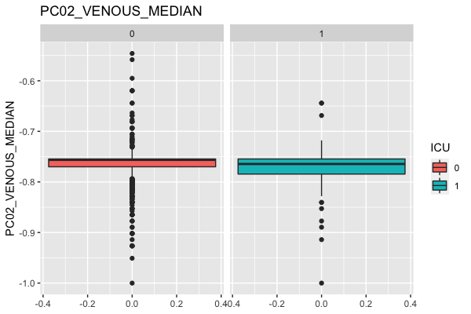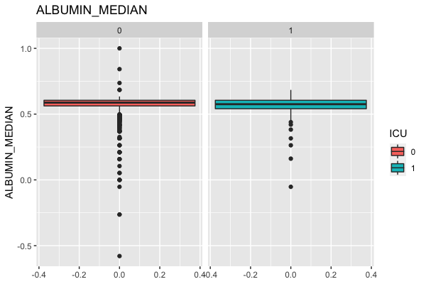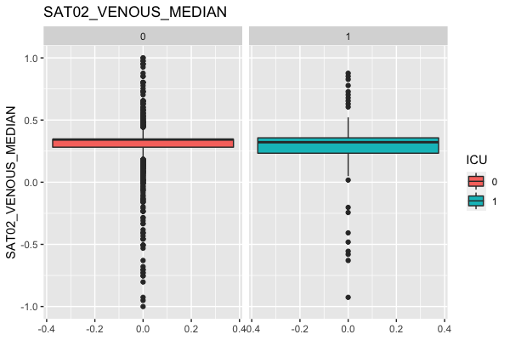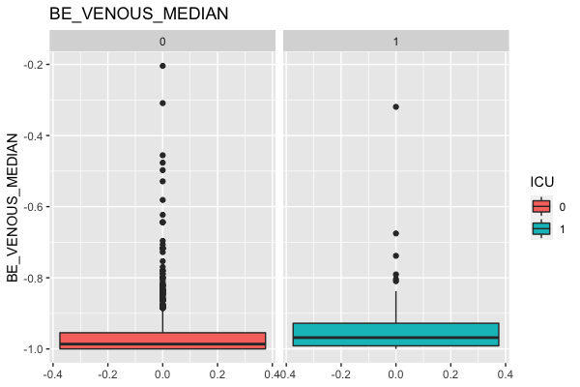

Figure 3J: Boxplots of PC02, SAT02 BE venous and albumin

*Figure 3I* shows various boxplots of continuous predictors against ICU. Instead of predicting if a patient needs to go to an ICU right at that moment, we are predicting if a patient is about to go into ICU from their vital signs. Thus, as seen from the data visualisation, there is no obvious difference between the boxplot for ICU = 0 and ICU = 1, which puts more emphasis on machine learning, as it is not possible to predict if a patient will require emergency care by just looking at individual predictors.

3.6 Data Modelling

The team has decided to compare 3 machine learning models. Using the values from the various models’ confusion matrices, we are able to calculate the false positive rate (FPR), false negative rate (FNR), overall error, precision, recall, and F1-score. The models were compared on these error matrices that will be elaborated in section 3.5.

For this dataset, we have chosen 3 machine learning models - Logistic Regression, Random Forest, and Neural Network. The reasonings for choosing these models and how these models are coded are similar to the previous dataset. The differences will be mentioned below.

Unlike the previous dataset which is relatively balanced, this dataset’s outcome variable is very unbalanced. For an unbalanced trainset, frequent cases will get fewer misclassifications (Stack Exchange, 2016), while seldom cases will get more misclassifications. When we trained random forest on our unbalanced trainset, the false negative rate is 1, which means that the model is unable to predict any ICU = 1. Even though this might be due to our small testset, we feel that since the objective of our model is to predict the patients whose illness might be severe enough to go ICU and focus more on those patients. We want to focus more on accurately predicting the positives, thus, we need to decrease the false negative rate by balancing the trainset.

For logistic regression, we used binomial instead of multinomial as the outcome variable for this dataset only has 2 levels.

For Random Forest, unlike the previous dataset which set ntree to the default value of 500, our OOB error for this dataset did not stabilise even after 500 trees, thus, we set ntree to 100000 as it only stabilises after 50000 trees.

For Neural Network, the team experimented with a 1-hidden layer and a 2-hidden layer neural network and found that the 2-hidden layer neural network achieved lower error.

Detailed model description, confusion matrix, model plots, and OOB error plot can be found in Appendix B.

3.7 Comparison of Models

*Table 3* below shows the summary of the errors of the 3 models (in %, rounded to 3 decimal places):

|  |  |  |  |  |  |  |
| --- | --- | --- | --- | --- | --- | --- |
| Model | FPR | FNR | Overall Error | Precision | Recall | F1 Score |
| Logistic Regression Train | 26.613% | 26.613% | 26.613% | 73.387% | 73.387% | 73.387% |
| Logistic Regression Test | 44.385% | 26.415% | 42.155% | 19.024% | 73.585% | 30.233% |
| Random Forest Train | 0.000% | 0.000% | 0.000% | 1.000% | 1.000% | 1.000% |
| Random Forest Test | 38.235% | 26.415% | 36.768% | 21.429% | 73.585% | 33.191% |
| Neural Network (1 level) Train | 0.000% | 0.000% | 0.000% | 1.000% | 1.000% | 1.000% |
| Neural Network (1 level) Test | 40.374% | 37.736% | 40.047% | 17.935% | 62.264% | 27.848% |
| Neural Network (2 level) Train | 0.000% | 0.000% | 0.000% | 1.000% | 1.000% | 1.000% |
| Neural Network (2 level) Test | 44.118% | 41.509% | 43.794% | 15.816% | 58.491% | 24.900% |

Table 3: Collated Error rates for ICU Admission Models

Precision can be defined as the ratio between the True Positives and all the Predicted Positives (Purva, 2020). In this case, it would be the measure of patients that we correctly identify that are about to go into ICU that will be going to ICU in the next window. Random Forest has the highest Precision at 21.429%, indicating that it is only correct 21.429% of the time when it predicts that a patient is about to go into ICU.

Recall is the measure of our model correctly identifying True Positives (Purva, 2020). Thus, for all the patients who are about to go into ICU, recall tells us how many we correctly identified as about to go into ICU. All the models generally have a high Recall, with Random Forest having the highest Recall along with Logistic Regression at 73.595%.

There is thus a trade-off between Precision and Recall. For our dataset, we can consider that achieving a high recall is more important than getting a high precision – we would like to detect as many patients that will require a higher level of care as possible. A low Precision compared to Recall would not pose any significant problem as patients who ultimately need a higher level of care are still ultimately receiving what they need. Thus, there is a need to balance our trainset to decrease the false negative rate and increase Recall.

F1-score is the harmonic mean of the Precision and Recall (Purva, 2020). Random Forest has both the highest F1-score and the lowest overall error; thus, our team will be choosing Random Forest as our preferred model.

4 Limitations

Due to the lack of access to patients’ clinical and personal data from online resources, we do not have a lot of data to work with. For our ICU dataset, there are only 1424 rows of data with more than 50% of the data missing. Instead of removing the NA values, we used rfImpute to replace the NA values, in order to have a larger dataset to work with. While inaccurate, this would suffice for a proof of concept of our framework and models. With greater access to an even larger variety and volume of data regarding covid patients, a stronger association is required. This can be done by potentially matching them with more than one variable of significant correlation, to create a more authentic and higher quality synthetic dataset that mimics real and original data from every patient.

The errors for our machine learning models for our ICU dataset are very high, indicating that the outcome that we have predicted is inaccurate. This is mainly due to the small amount of data that we are working with, thus our models are not trained enough. However, if MOH decides to implement our framework, with accessibility to more data given by hospitals, we believe that the errors will drop, resulting in significantly more accurate models.

Given the small size of both our datasets with just slightly over 2000 data rows for our first model and about 1400 data rows for our second model, we recognise that the models are not the most optimal as they are based on relatively small data size. Thus, we would require the collection of even more data for both models, to train a more accurate model.

5 Conclusion

In conclusion, both our models attempt to provide a data-driven machine learning approach to predict both the severity of one’s COVID-19 condition and whether a hospital patient is likely to be admitted into ICU or not. These models strive to help healthcare institutions to maximise the allocation of their limited healthcare resources and reduce the amount of healthcare wastage.

The Severity Prediction Model was able to accurately predict 98.7% of cases with a 100% prediction rate for Moderate and Severe cases. Based on the dataset, 63.66% of the data are mild cases and if MOH were to implement this, a huge portion of the load on hospitals would be reduced. While it is also true that not all covid positive cases would be visiting a hospital, a significant portion of those who do visit are indeed mild cases and would have been filtered to stay at home using our CheckTogether App.

The ICU Admission Model was also able to accurately predict 63.2% of cases with a high Recall percentage of 73.6%, indicating that for all the patients that require intensive care soon and are about to go into ICU, 73.6% are predicted correctly by our model, thus giving them the required treatment first before their conditions deteriorated more such that they need to go into ICU. Since prevention is better than cure, our ICUChecker software will be able to accurately predict the patients that will be going to ICU in the next window and provide them the necessary care to prevent deterioration of the patient's condition to a state of emergency treatment in the next window.

Overall, the usefulness of our Models would thus be able to help hospitals better allocate their resources and hasten their decision-making.

APPENDIX A: R Outputs of Severity Prediction Model

Multinomial Logistic Regression Model

Full Logistic Regression Model:

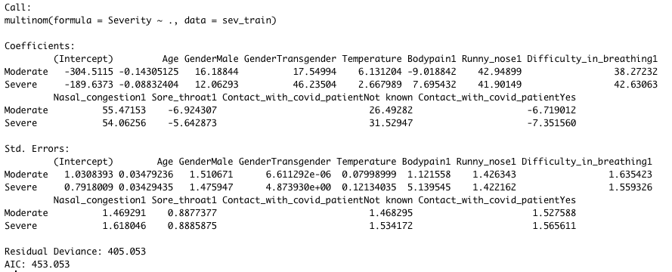

Logistic Regression Model with Backward Elimination:

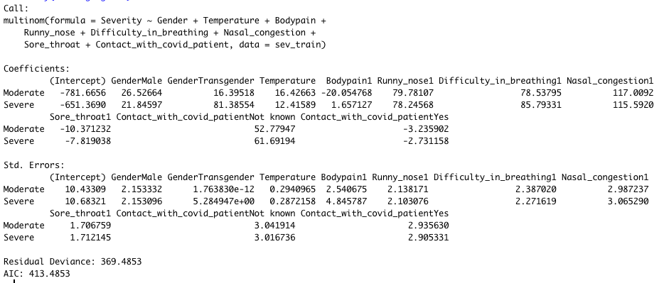

Train Set Confusion Matrix for Logistic Regression Model with Backward Elimination: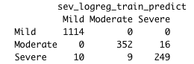

Test Set Confusion Matrix for Logistic Regression Model with Backward Elimination: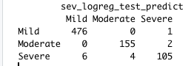

Random Forest Model

Full Model:

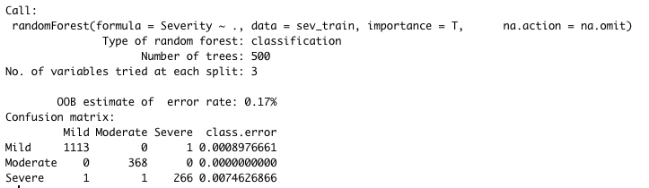

OOB Error Plot:

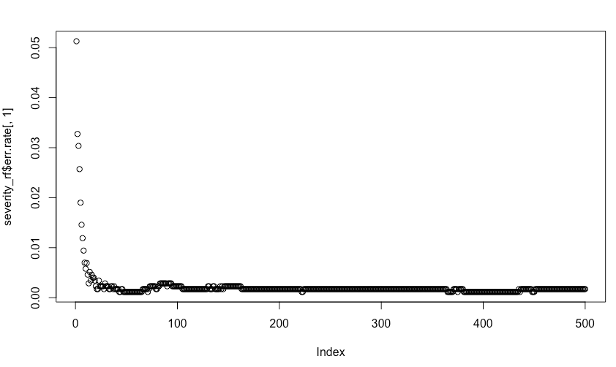

Train Set Confusion Matrix for Random Forest Model:

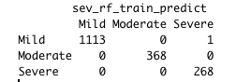

Test Set Confusion Matrix for Random Forest Model:

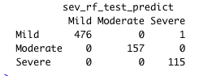

Neural Network Model

1-Hidden Level Neural Network Model:

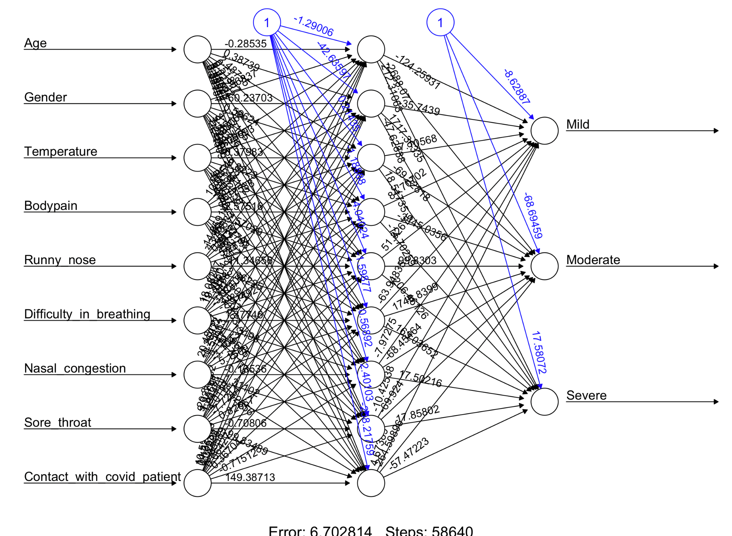

Train Set Confusion Matrix for 1-Hidden Level Neural Network Model:

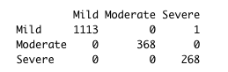

Test Set Confusion Matrix for 1-Hidden Level Neural Network Model:

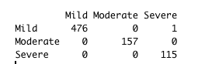

2-Hidden Level Neural Network Model:

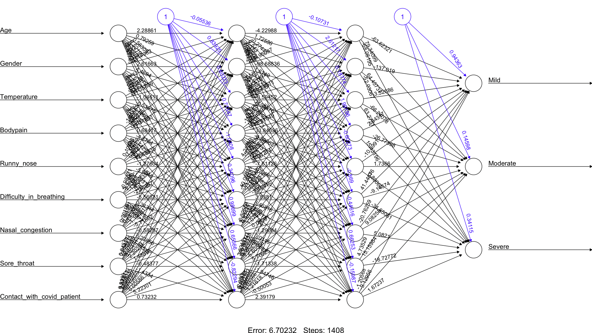

Train Set Confusion Matrix for 2-Hidden Level Neural Network Model:

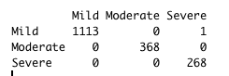

Test Set Confusion Matrix for 2-Hidden Level Neural Network Model:

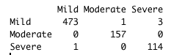

Comparison of Error between 1-Hidden & 2-Hidden Layer Neural Network Model:

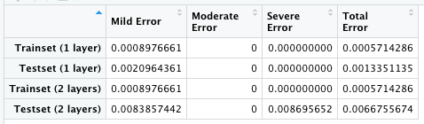

Comparison of All Models

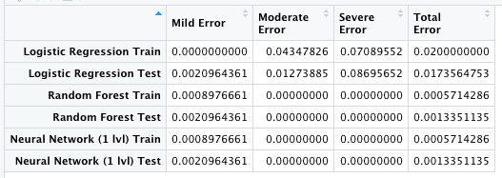

APPENDIX B: R Outputs of ICU Admission Model

Multinomial Logistic Regression Model

Full Logistic Regression Model:

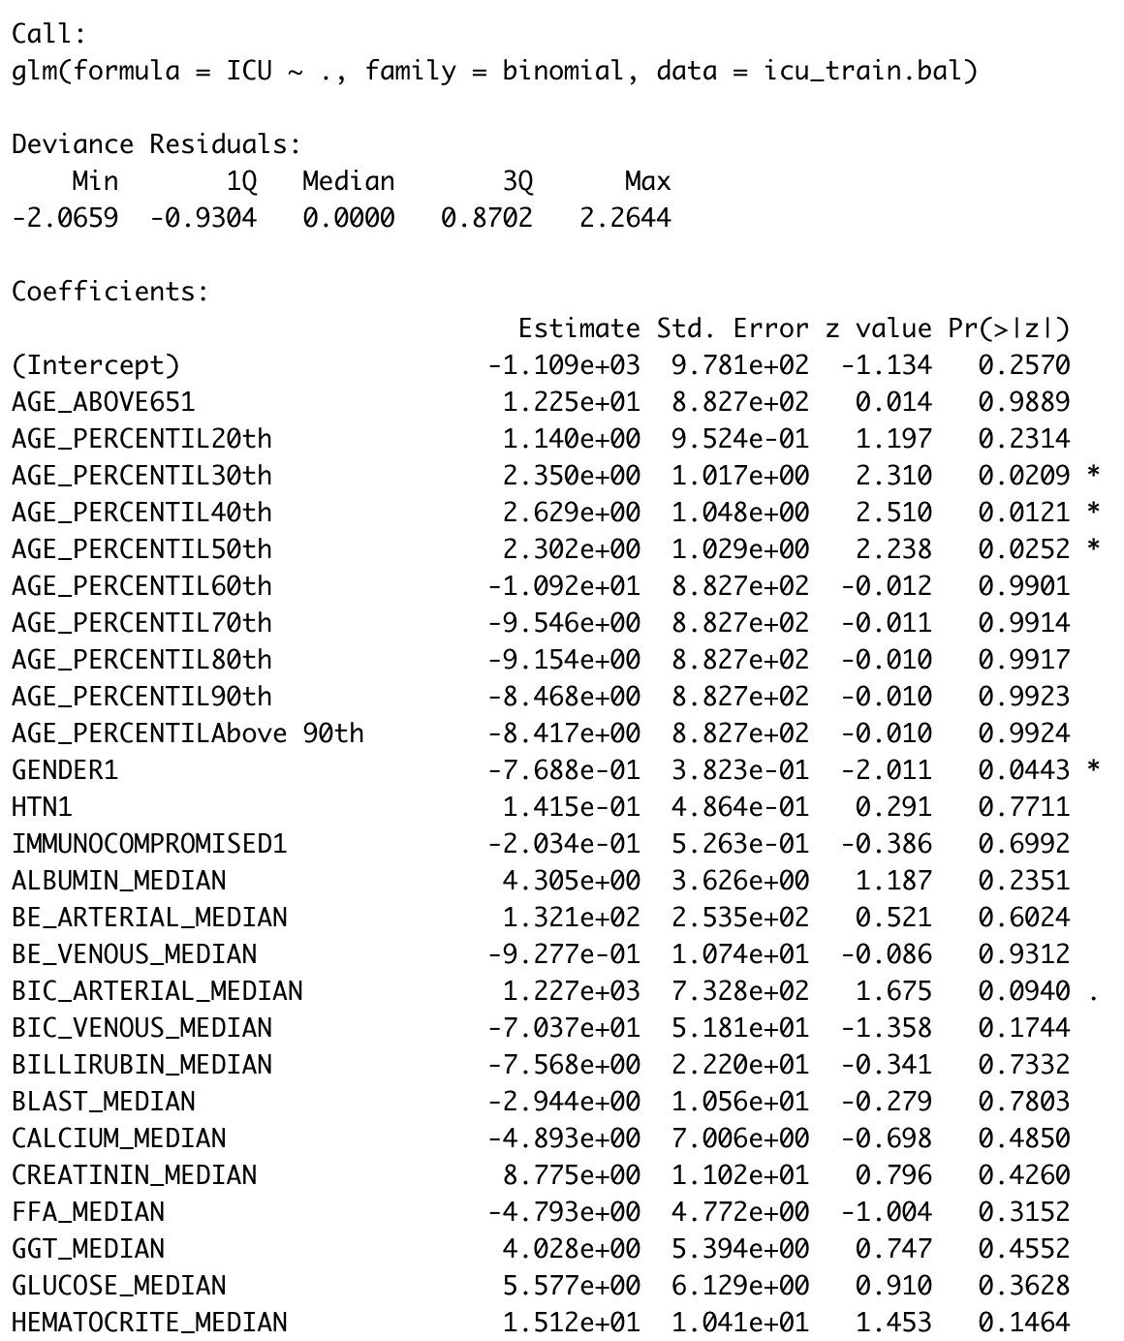

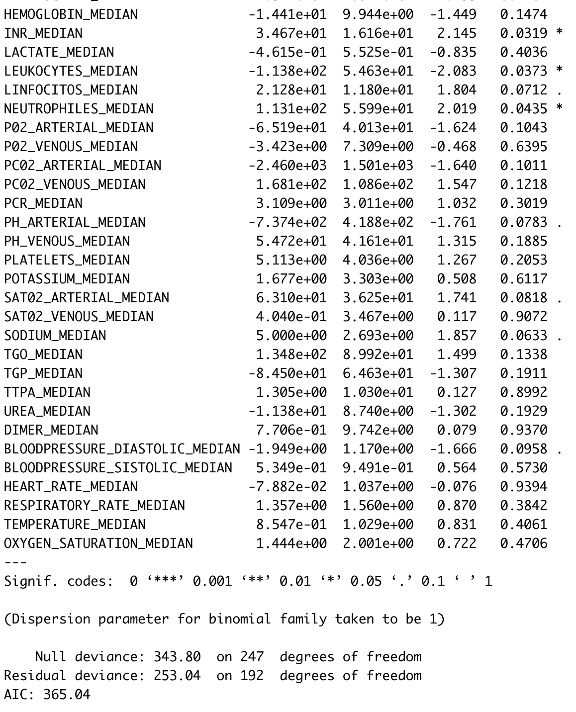

Logistic Regression Model with Backward Elimination:

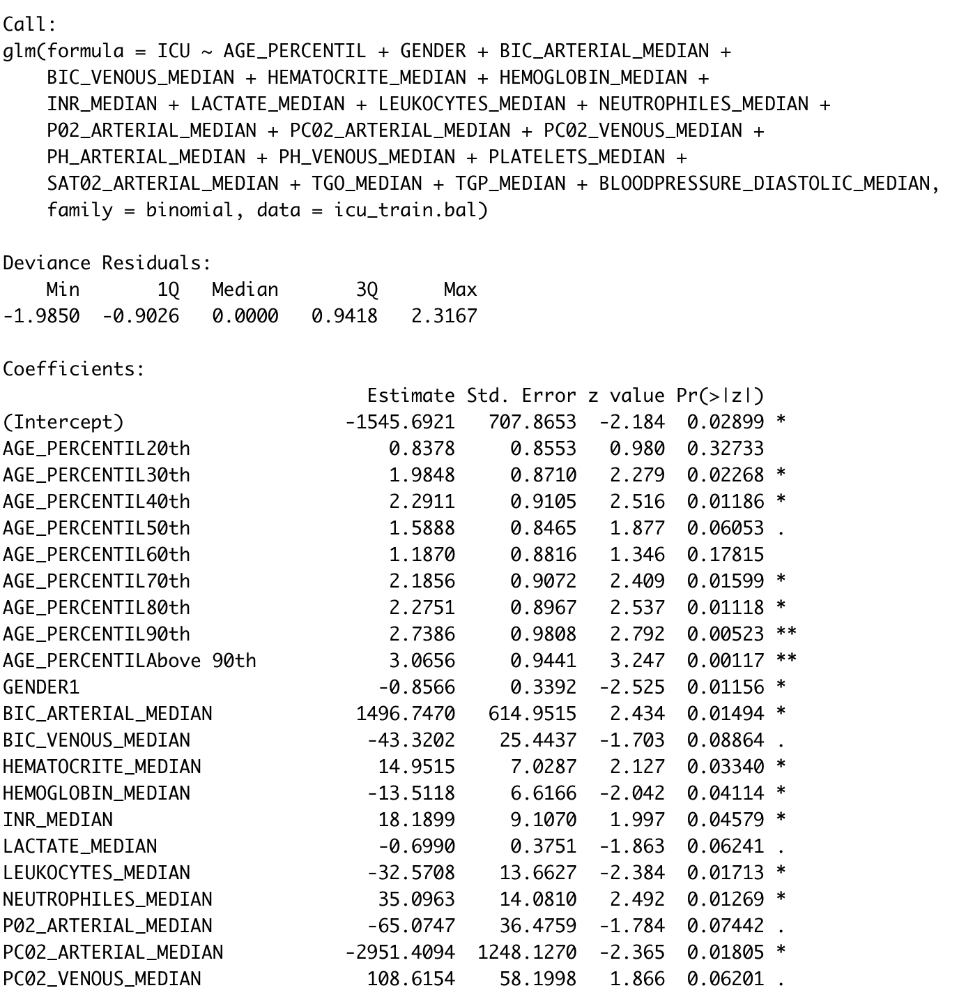

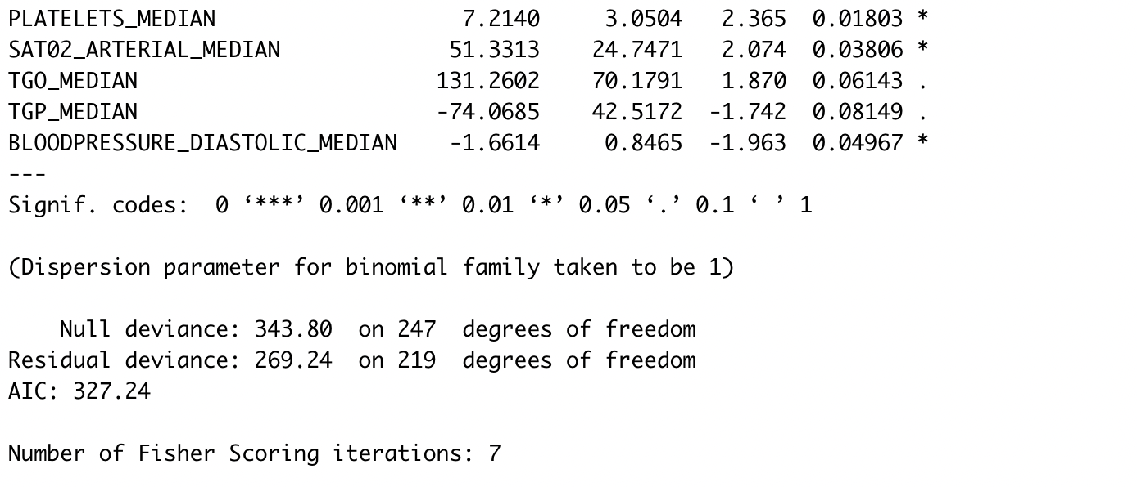

Train Set Confusion Matrix for Logistic Regression Model with Backward Elimination:

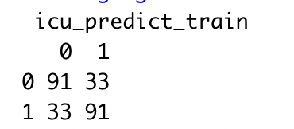

Test Set Confusion Matrix for Logistic Regression Model with Backward Elimination:

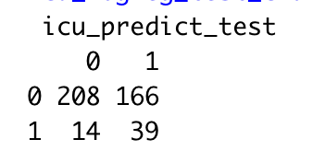

Random Forest Model

Full Model:

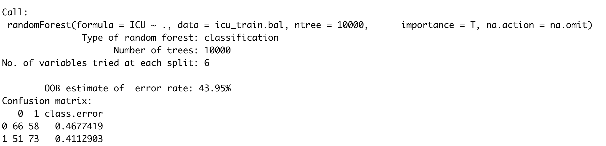

OOB Error Plot:

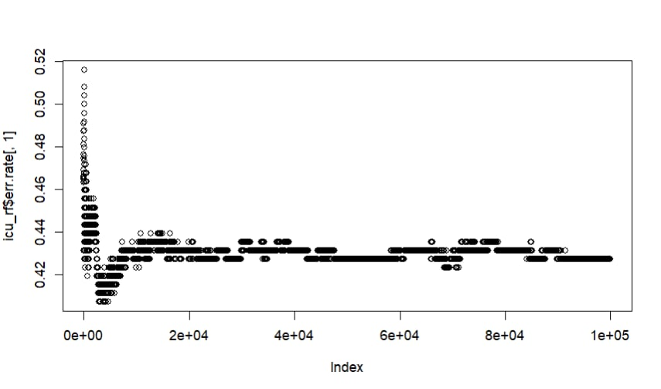

Train Set Confusion Matrix for Random Forest Model:

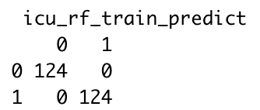

Test Set Confusion Matrix for Random Forest Model:

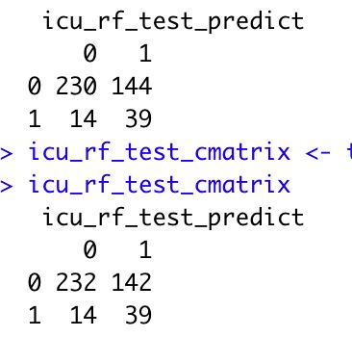

Neural Network Model

1-Hidden Level Neural Network Model:

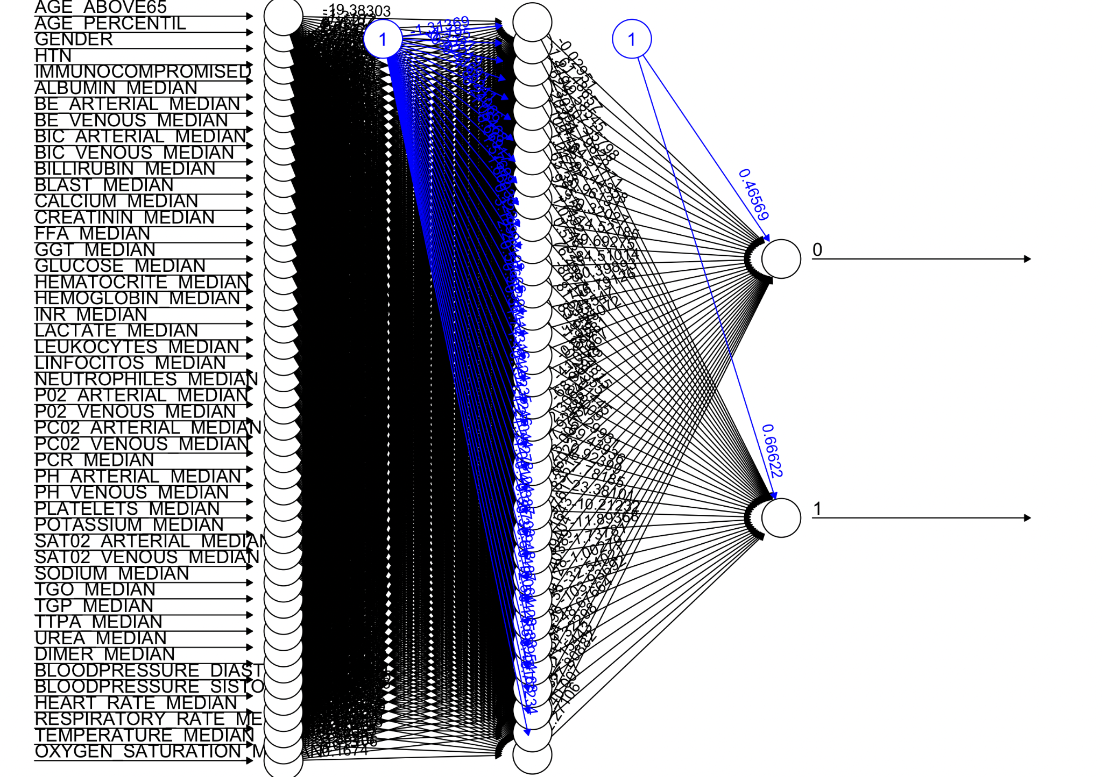

Train Set Confusion Matrix for 1-Hidden Level Neural Network Model:



Test Set Confusion Matrix for 1-Hidden Level Neural Network Model:

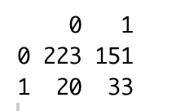

2-Hidden Level Neural Network Model:

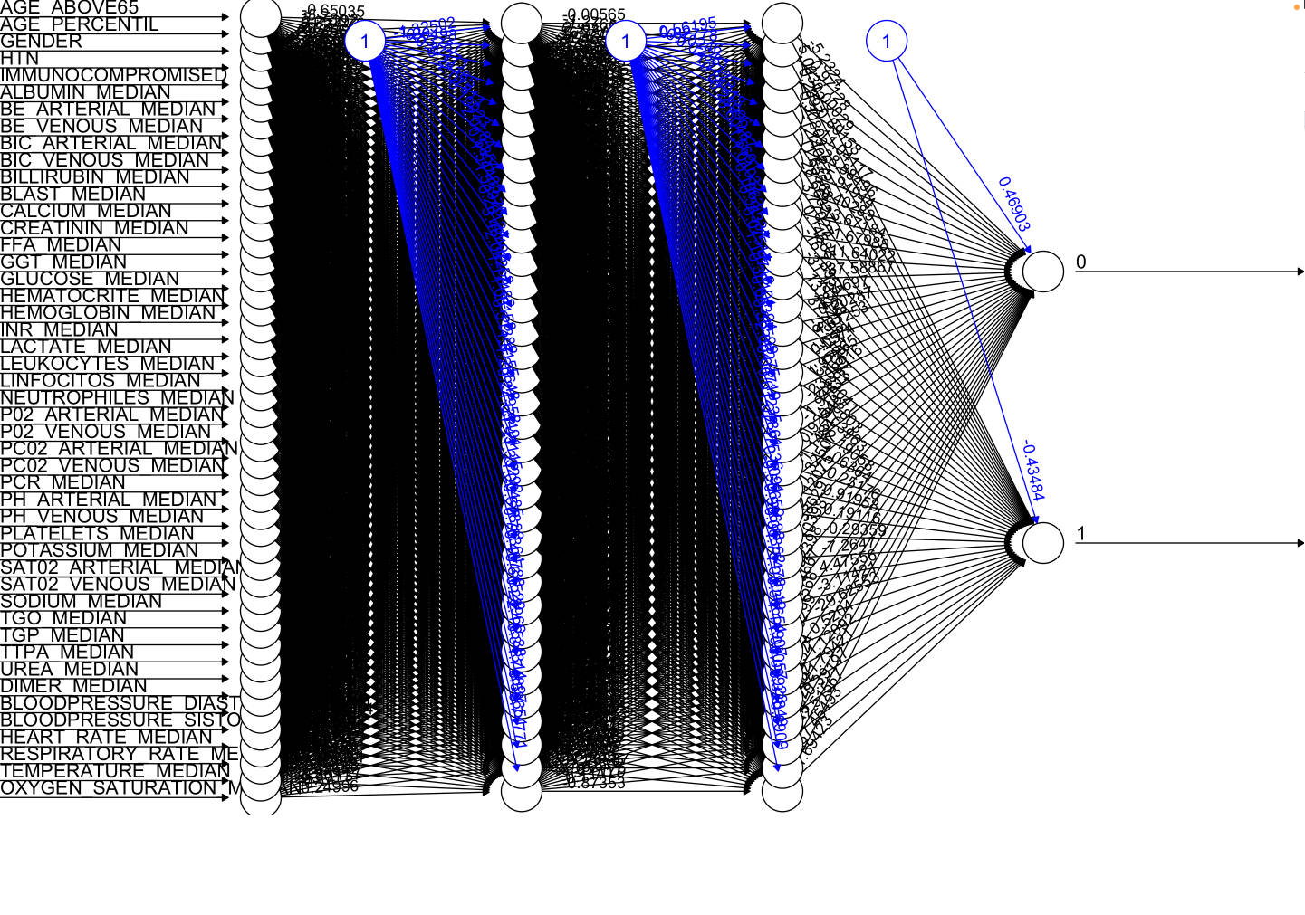

Train Set Confusion Matrix for 2-Hidden Level Neural Network Model:



Test Set Confusion Matrix for 2-Hidden Level Neural Network Model:

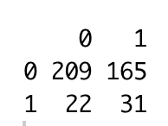

Comparison of All Models

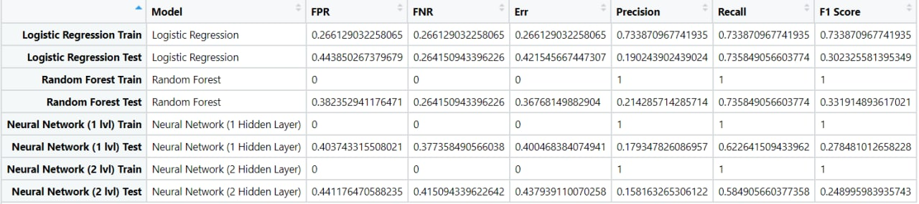

APPENDIX C: Data Dictionary

Severity Prediction Model

|  |  |  |  |
| --- | --- | --- | --- |
| **Variable Name** | **Data Type** | **Variable Type** | **Remarks** |
| Severity | Factor | Categorical | **Outcome Variable**  3 levels:  Mild, Moderate, Severe |
| Age | Numeric | Continuous | Age of the patient on admission |
| Gender | Factor | Categorical | 3 levels:  Male, Female, Transgender |
| Temperature | Numeric | Continuous | Last recorded temperature of patient in degrees celsius |
| Bodypain | Factor | Categorical | 0: Patient does not experience body pain  1: Patient experiences body pain |
| Runny_nose | Factor | Categorical | 0: Patient does not experience runny nose  1: Patient experiences runny nose |
| Difficulty_in_breathing | Factor | Categorical | 0: Patient does not experience difficulty in breathing  1: Patient experiences difficulty in breathing |
| Nasal_congestion | Factor | Categorical | 0: Patient does not experience nasal congestion  1: Patient experiences nasal congestion |
| Sore_throat | Factor | Categorical | 0: Patient does not experience sore throat  1: Patient experiences sore throat |
| Contact_with_covid_patient | Factor | Categorical | 0: Patient has come into contact with a COVID-19 positive patient within 7 days prior to infection  1: Patient has not come into contact with a COVID-19 positive patient within 7 days prior to infection |

ICU Admission Model

|  |  |  |  |
| --- | --- | --- | --- |
| **Variable Name** | **Data Type** | **Variable Type** | **Remarks** |
| ICU | Factor | Categorical | **Outcome Variable**  2 levels:  0: Patient not entering ICU  1: Patient entering ICU in next window |
| AGE_ABOVE65 | Factor | Categorical | 0: Age 65 and below  1: Age above 65 |
| AGE_PERCENTIL | Factor | Categorical | 10 level: 10,20,..,90th, above 90th percentile |
| GENDER | Numeric | Continuous | 2 levels: Male, Female |
| HTN | Factor | Categorical | 0: Patient does not have HyperTension  1: Patient has HyperTension |
| IMMUNOCOMPROMISED | Factor | Categorical | 0: Patient is not Immunocompromised  1: Patient is Immunocompromised |
| ALBUMIN_MEDIAN | Numeric | Continuous | Patient’s last recorded Albumin |
| BE_ARTERIAL_MEDIAN | Numeric | Continuous | Patient’s last recorded Base Excess arterial blood gas |
| BE_VENOUS_MEDIAN | Numeric | Continuous | Patient’s last recorded Base Excess of venous blood gas |
| BIC_ARTERIAL_MEDIAN | Numeric | Continuous | Patient’s last recorded Bicarbonate of arterial blood gas |
| BIC_VENOUS_MEDIAN | Numeric | Continuous | Patient’s last recorded Bicarbonate of venous blood gas |
| BILLIRUBIN_MEDIAN | Numeric | Continuous | Patient’s last recorded Bilirubin |
| BLAST_MEDIAN | Numeric | Continuous | Patient’s last recorded Basic Local Alignment Search Tool (BLAST) |
| CALCIUM_MEDIAN | Numeric | Continuous | Patient’s last recorded Calcium level |
| CREATININ_MEDIAN | Numeric | Continuous | Patient’s last recorded Creatinine level |
| FFA_MEDIAN | Numeric | Continuous | Patient’s last recorded Free Fatty Acid (FFA) |
| GGT_MEDIAN | Numeric | Continuous | Patient’s last recorded Gamma-Glutamyl Transferase (GGT) |
| GLUCOSE_MEDIAN | Numeric | Continuous | Patient’s last recorded Glucose level |
| HEMATOCRITE_MEDIAN | Numeric | Continuous | Patient’s last recorded Hematocrit level |
| HEMOGLOBIN_MEDIAN | Numeric | Continuous | Patient’s last recorded Haemoglobin level |
| INR_MEDIAN | Numeric | Continuous | Patient’s last recorded International Normalised Ratio |
| LACTATE_MEDIAN | Numeric | Continuous | Patient’s last recorded Lactic Acid level |
| LEUKOCYTES_MEDIAN | Numeric | Continuous | Patient’s last recorded Leukocytes level |
| LINFOCITOS_MEDIAN | Numeric | Continuous | Patient’s last recorded Linfocitos level |
| NEUTROPHILES_MEDIAN | Numeric | Continuous | Patient’s last recorded Neutrophiles level |
| P02_ARTERIAL_MEDIAN | Numeric | Continuous | Patient’s last recorded P02 of arterial blood |
| P02_VENOUS_MEDIAN | Numeric | Continuous | Patient’s last recorded P02 of venous blood |
| PCR_MEDIAN | Numeric | Continuous | Patient’s last recorded Polymerase Chain Reaction (PCR) level |
| PH_ARTERIAL_MEDIAN | Numeric | Continuous | Patient’s last recorded PH level of arterial blood |
| PH_VENOUS_MEDIAN | Numeric | Continuous | Patient’s last recorded PH level of venous blood |
| PLATELETS_MEDIAN | Numeric | Continuous | Patient’s last recorded Platelets level |
| POTASSIUM_MEDIAN | Numeric | Continuous | Patient’s last recorded Potassium level |
| SAT02_ARTERIAL_MEDIAN | Numeric | Continuous | Patient’s last recorded SAT02 of arterial blood |
| SAT02_VENOUS_MEDIAN | Numeric | Continuous | Patient’s last recorded SAT02 of venous blood |
| SODIUM_MEDIAN | Numeric | Continuous | Patient’s last recorded Sodium level |
| TGO_MEDIAN | Numeric | Continuous | Patient’s last recorded bicarbonate of venous blood |
| TGP_MEDIAN | Numeric | Continuous | Patient’s last recorded Therapeutic Goods Order |
| TTPA_MEDIAN | Numeric | Continuous | Patient’s last recorded Alpha Tocopherol Transfer Protein |
| UREA_MEDIAN | Numeric | Continuous | Patient’s last recorded Urea Nitrogen level |
| DIMER_MEDIAN | Numeric | Continuous | Patient’s last recorded D-Dimer level |
| BLOODPRESSURE_DIASTOLIC_MEDIAN | Numeric | Continuous | Patient’s last recorded Diastolic Blood Pressure |
| BLOODPRESSURE_SISTOLIC_MEDIAN | Numeric | Continuous | Patient’s last recorded Systolic Blood Pressure |
| HEART_RATE_MEDIAN | Numeric | Continuous | Patient’s last recorded Heart Rate |
| RESPIRATORY_RATE_MEDIAN | Numeric | Continuous | Patient’s last recorded Respiratory Rate |
| TEMPERATURE_MEDIAN | Numeric | Continuous | Patient’s last recorded Temperature |
| OXYGEN_SATURATION_MEDIAN | Numeric | Continuous | Patient’s last recorded Oxygen Saturation level |

*All continuous data variables are scaled according to a min max scaler to fit between the values -1 and 1

*We took the median of all the continuous data variables

APPENDIX D: Usage Roadmap of Mobile Application

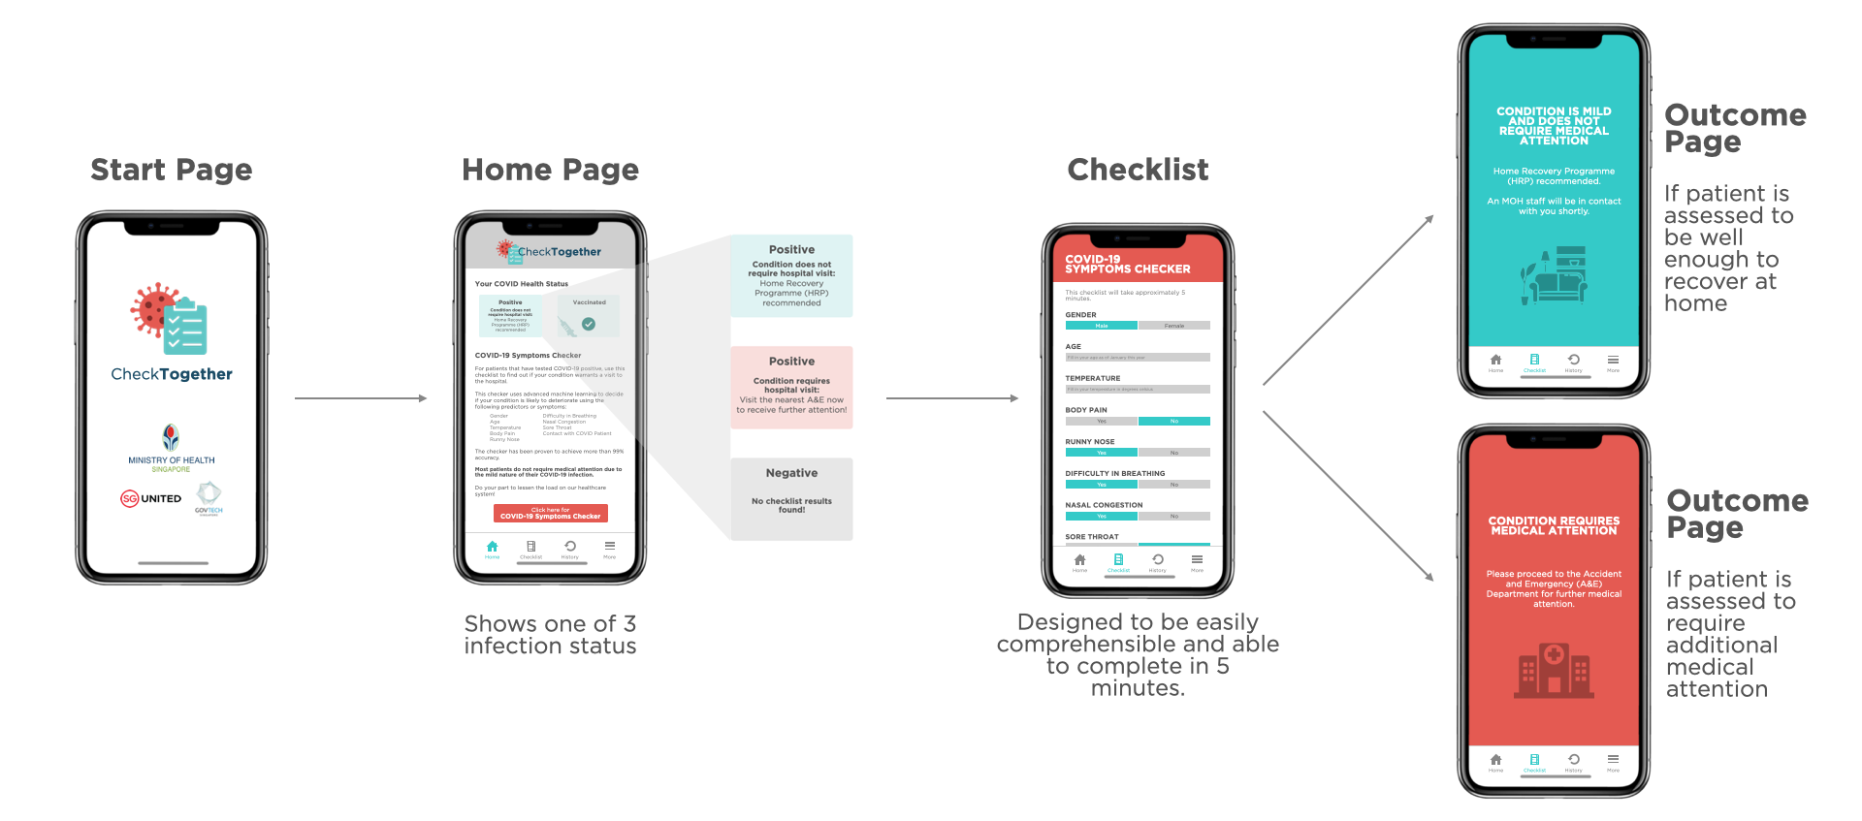

APPENDIX E: Usage Roadmap of ICU Checker Software

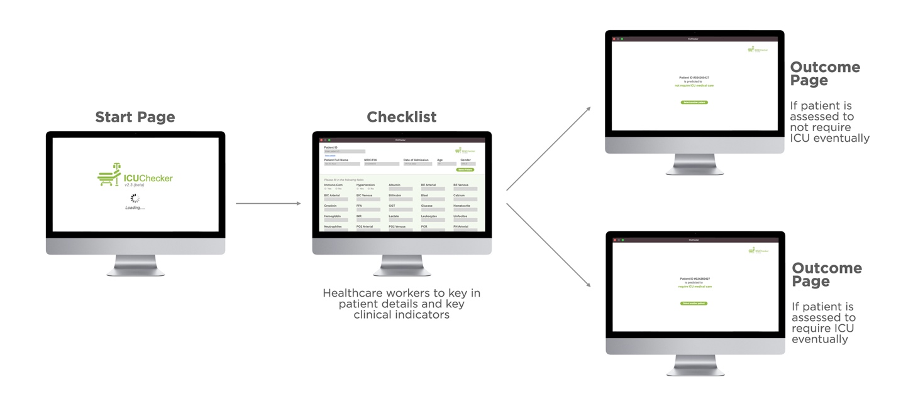

Appendix F: Data Cleaning

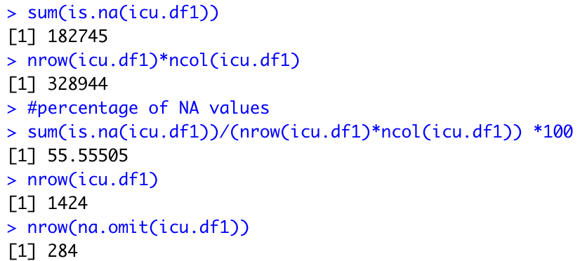

Appendix G: Data Exploration

Severity Dataset

# Continuous Variables

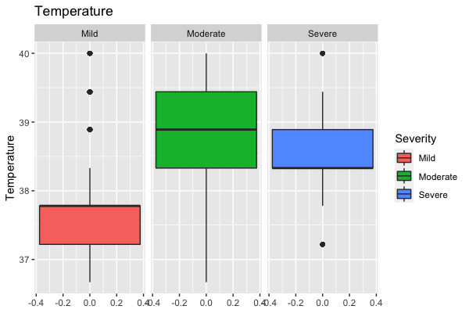



# Categorical Variables

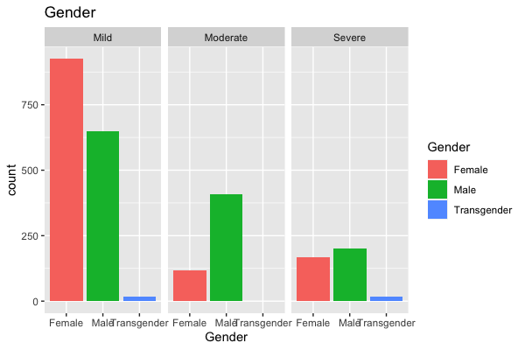

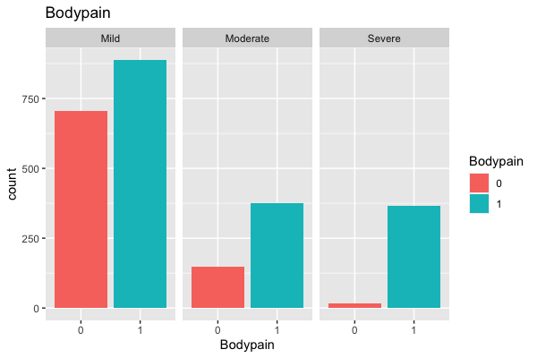

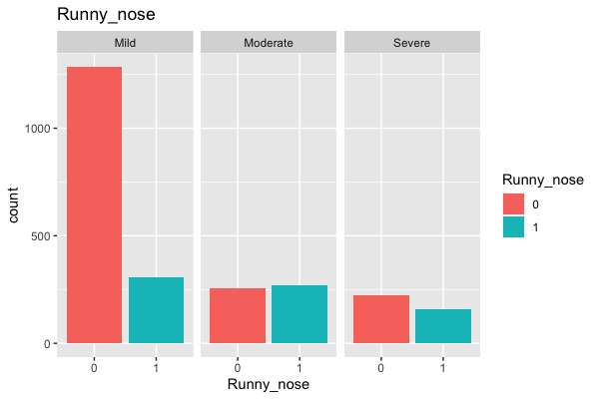

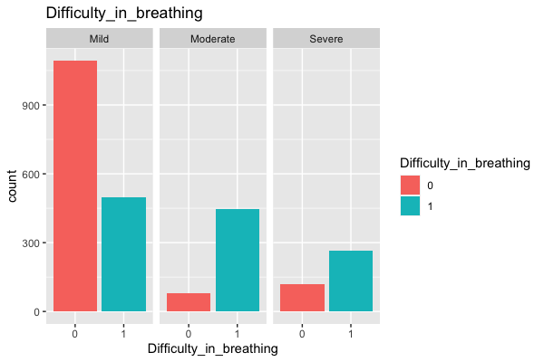



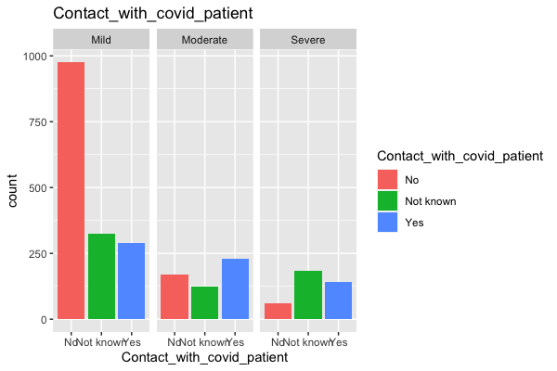

ICU Dataset

Continuous Variables

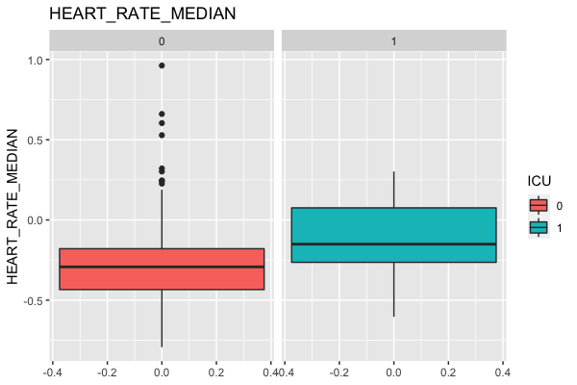





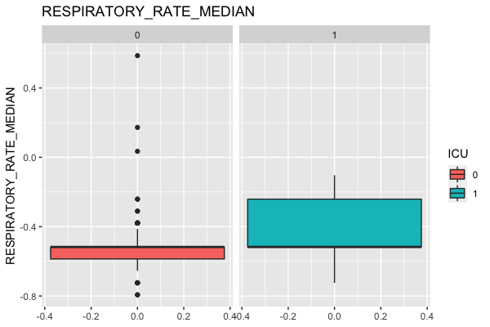



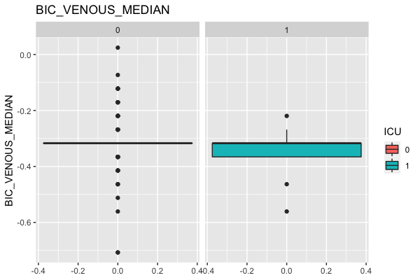

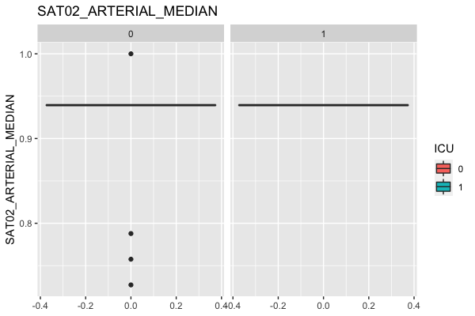

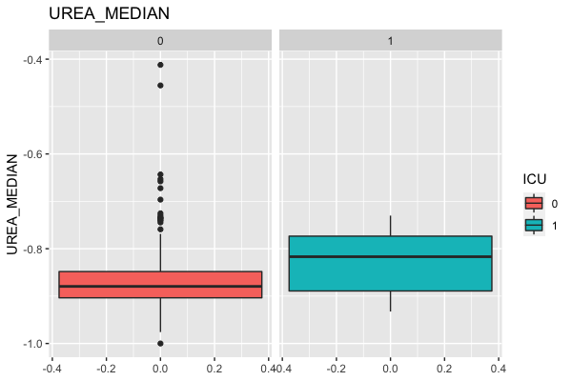

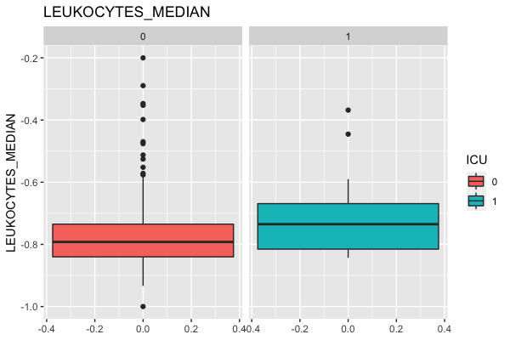



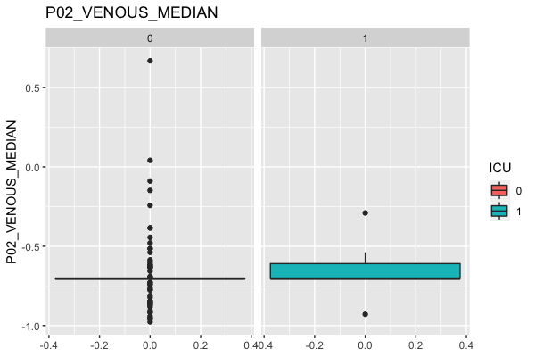

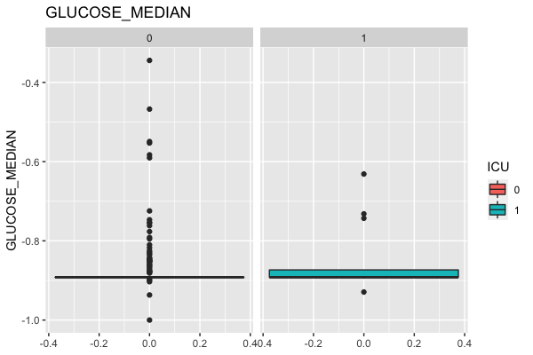



# Categorical Variables



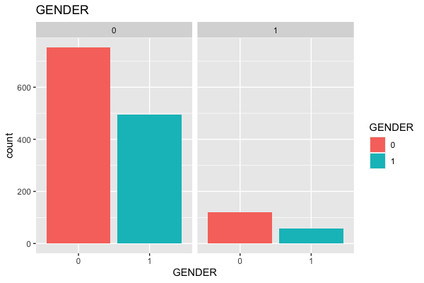

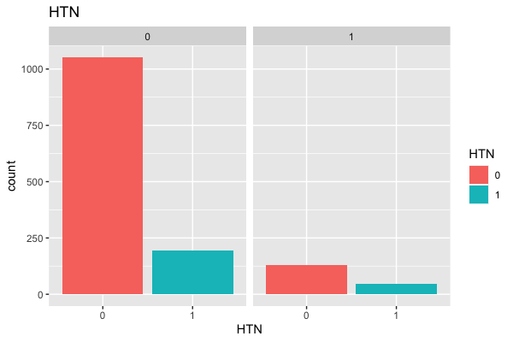

APPENDIX H: References

Lai, L. (2021, October 23). *How close is Singapore's healthcare system to its breaking point?* Retrieved from The Straits Times: https://www.straitstimes.com/singapore/health/still-risk-of-healthcare-system-reaching-tipping-point-0

Woon, W. (2022, February 24). *Doctors, nurses struggle to cope as Covid-19 patients flock to A&E depts, many with mild symptoms*. Retrieved from The Straits Times: https://www.straitstimes.com/singapore/health/doctors-nurses-struggle-to-cope-as-covid-19-patients-flock-to-ae-depts-many-with-mild-symptoms

Abu Baker, J., & Mohan, M. (2020, May 4). *Stretched but coping: How Singapore's healthcare system has cranked up efforts to deal with COVID-19*. Retrieved from Channel News Asia: https://www.channelnewsasia.com/singapore/covid-19-singapore-health-capacity-hospitals-treatment-935336

Teo, J. (2021, November 8). *Singapore hospitals under significant pressure; two-thirds of ICU beds occupied*. Retrieved from The Straits Times: https://www.straitstimes.com/singapore/health/singapore-hospitals-under-significant-pressure-two-thirds-of-covid-19-icu-beds

Plump, A. (2021, May 18). *Luck is not a strategy: The world needs to start preparing now for the next pandemic*. Retrieved from StatNews: https://www.statnews.com/2021/05/18/luck-is-not-a-strategy-the-world-needs-to-start-preparing-now-for-the-next-pandemic/

French, G., Hulse, M., Nguyen, D., Sobotka, K., Webster, K., Corman, J., . . . Ewing, M. (2021, November 19). *Impact of Hospital Strain on Excess Deaths During the COVID-19 Pandemic*. Retrieved from Centers for Disease Control and Prevention: https://www.cdc.gov/mmwr/volumes/70/wr/mm7046a5.htm

Lim, V., & Ang, H. (2022, February 11). *Healthcare workers describe struggles as patients flood emergency rooms amid Omicron wave* . Retrieved from Channel News Asia: https://www.channelnewsasia.com/singapore/healthcare-workers-describe-struggles-patients-flood-emergency-rooms-amid-omicron-wave-2492571

Ang, H. (2021, September 24). *Rapidly rising COVID-19 cases putting 'serious strain' on hospitals, action needed: Task force*. Retrieved from Channel News Asia: https://www.channelnewsasia.com/singapore/covid19-rising-cases-strain-hospitals-gan-kim-yong-mtf-2199546

Low, D. (2021, October 20). *Singapore's Record Cases Sparks Warning Of Strain On Hospitals*. Retrieved from Bloomberg: https://www.bloomberg.com/news/articles/2021-10-20/singapore-s-record-cases-sparks-warning-of-strain-on-hospitals#:~:text=Tracking%20Covid%2D19&text=New%20daily%20cases%20hit%203%2C994,Health%20said%20in%20a%20statement.&text=“The%20number%20of%20persons%

Yong, N. (2021, November 1). *Singapore can ramp up ICU capacity but 'not enough people': Janil Puthucheary*. Retrieved from Yahoo! News: https://sg.news.yahoo.com/singapore-ramp-up-icu-capacity-not-enough-people-janil-puthucheary-061622932.html

Covino, M., Sandroni, C., Santoro, M., Sabia, L., Simeoni, B., Bocci, M., . . . Franceschi, F. (2020, November). Predicting intensive care unit admission and death for COVID-19 patients in the emergency department using early warning scores. *Elsevier Public Health Emergency Collection*(156), 84-91.

Pandey, S. (2020, May 13). *Covid-19-prediction / Madedata1.csv.* Retrieved from Github: https://github.com/Simranpandey16/Covid-19-prediction/blob/master/Madedata1.csv

COVID-19 Clinical Management Committee (CCMC). (2021, April 15). *Interim COVID-19 Clinical Management Guidelines.* Retrieved from Ministry of Health Singapore: https://www.moh.gov.sg/docs/librariesprovider4/default-document-library/interim-covid-19-clinical-management-guidelines-(full-document).pdf

Goyal, C. (2021, May 28). *20+ Questions to Test your Skills on Logistic Regression* . Retrieved from Analytics Vidhya: https://www.analyticsvidhya.com/blog/2021/05/20-questions-to-test-your-skills-on-logistic-regression/

Pramoditha, R. (2021, October 4). *How to Mitigate Overfitting with Feature Selection* . Retrieved from Towards Data Science: https://towardsdatascience.com/how-to-mitigate-overfitting-with-feature-selection-164897c0c3db

Kumar, N. (2019, February 23). *Advantages and Disadvantages of Random Forest Algorithm in Machine Learning*. Retrieved from The Professionals Point: http://theprofessionalspoint.blogspot.com/2019/02/advantages-and-disadvantages-of-random.html

Brownlee, J. (2019, November 22). *3 Ways to Encode Categorical Variables for Deep Learning* . Retrieved from Machine Learning Mastery: https://machinelearningmastery.com/how-to-prepare-categorical-data-for-deep-learning-in-python/

Roßbach, P. (2018, October). *Neural Networks vs. Random Forests – Does it always have to be Deep Learning?* Retrieved from Frankfurt School of Finanace & Management: https://blog.frankfurt-school.de/wp-content/uploads/2018/10/Neural-Networks-vs-Random-Forests.pdf

American Heart Association. (2021, March 9). *Target Heart Rates Chart .* Retrieved from American Heart Association: https://www.heart.org/en/healthy-living/fitness/fitness-basics/target-heart-rates

Fletcher, J. (2018, July 9). *What does a serum albumin test tell you? .* Retrieved from Medical News Today: https://www.medicalnewstoday.com/articles/322403

Huan, H., Zaichao, X., Xiaoming, C., Youquan, Z., Yuan, L., Fubing, W., . . . Yuchen, X. (2020, October 24). *Descriptive, Retrospective Study of the Clinical Characteristics of Asymptomatic COVID-19 Patients.* Retrieved from mSphere, 2020; 5 (5): https://www.sciencedaily.com/releases/2020/10/201014141034.htm

Stack Exchange. (2016, August 3). *When should I balance classes in a training data set?* Retrieved from Stack Exchange: https://stats.stackexchange.com/questions/227088/when-should-i-balance-classes-in-a-training-%20data-set

Bhalla, D. (n.d.). *Missing Value Imputations With Random Forest.* Retrieved from Listen Data: https://www.listendata.com/2015/04/missing-value-imputations-with-random.html

Purva. (2020, September 4). *Precision vs. Recall – An Intuitive Guide for Every Machine Learning Person.* Retrieved from Analytics Vidhya: https://www.analyticsvidhya.com/blog/2020/09/precision-recall-machine-learning/